|  |
| --- |
| **SEDCO**  **CVM TEAM**  **Survey Question Configurator**  **Code Documentation** |

Table of Contents

Chapter 1: Developer 1

# Chapter 1: Developer

**1.1 Design Overview**

**1.1.1 Database Design**

The figure below shows database entity-relation diagram.

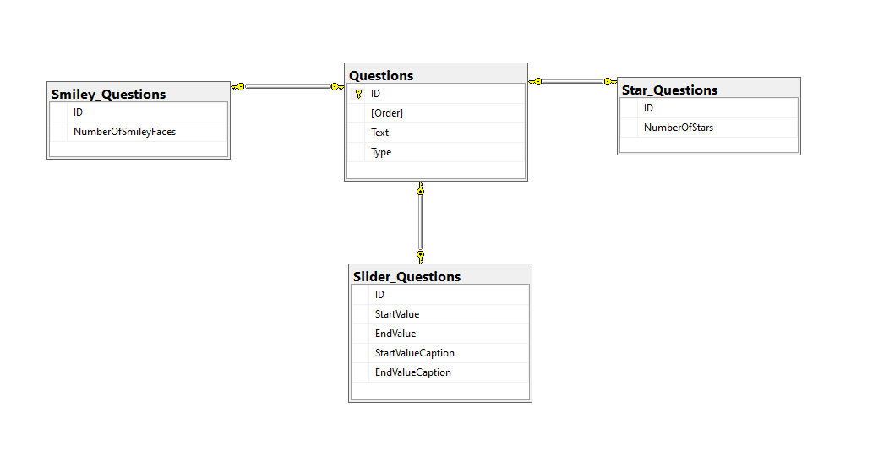

*Notes on tables:

1. Questions table:
   1. Types
2. ID [INT].
3. Order [INT].
4. Text [nvarchar(4000)].
5. Type [INT].
   1. Constraints
      * ID -> auto increment primary key.
      * Order -> Unique key.
      * Text -> Less than 4000 characters.
      * Type -> must be 0 or 1 or 2.
        + 0 -> Smiley type question.
        + 1-> Slider type question.
        + 2-> Star type question.
6. Smiley_Questions
   1. Types
      * ID [INT].
      * NumberOfSmileyFaces [INT].
   2. Constraints
      * ID-> Foreign key + Unique key + NOT NULL.
        + On update cascade
        + On delete cascade
      * NumberOfSmileyFaces -> Between 2 and 5 **inclusive**.
7. Slider_Questions
   1. Types
      * ID [INT].
      * StartValue [INT].
      * EndValue [INT].
      * StartValueCaption [nvarchar(100)].
      * EndValueCaption [nvarchar(100)].
   2. Constraints
      * ID-> Foreign key + Unique key + NOT NULL.
        + On update cascade
        + On delete cascade
      * StartValue -> Between 1 and 99 **inclusive**.
      * EndValue -> Between 2 and 100 **inclusive**.
      * StartValueCaption-> Less than 100 characters.
      * EndValueCaption-> Less than 100 characters.
8. Star_Questions
   1. Types
      * ID [INT].
      * NumberOfStars [INT].
   2. Constraints
      * ID-> Foreign key + Unique key + NOT NULL.
        + On update cascade
        + On delete cascade
      * NumberOfStars-> Between 1 and 10 **inclusive**.

**1.1.2 Stored Procedures**

There are 6 stored procedures.

3 for inserting questions

1. INSERT_SMILEY_QUESTION
2. INSERT_SLIDER_QUESTION
3. INSERT_STAR_QUESTION

And 3 for updating questions

1. UPDATE_SMILEY_QUESTION
2. UPDATE_SLIDER_QUESTION
3. UPDATE_STAR_QUESTION

**INSERT_SMILEY_QUESTION:**

**Paramters:**

@ORDER INT,

@TEXT NVARCHAR(4000),

@TYPE INT,

@NumberOfSmileyFaces INT

**Description:**

Takes Parameters and insert into 2 tables:

First, insert Order, Text and type into the [Questions] table Then it carries the ID from the first operation and insert it along with NumberOfSmileyFaces into the [Smiley_Questions] table.

**Returns:**

A table with the either success or error as ErrorCode column, and ERROR_MESSAGE() as ErrorMessage column.

SUCCESS = 1

ERROR = -1

**INSERT_SLIDER_QUESTION:**

**Paramters:**

@Order INT,

@Text NVARCHAR(4000),

@Type INT,

@StartValue INT,

@EndValue INT,

@StartValueCaption nvarchar(100),

@EndValueCaption nvarchar(100)

**Description:**

Takes Parameters and insert into 2 tables:

First, insert Order, Text and type into the [Questions] table Then it carries the ID from the first operation and insert it along with Start & End values and their captions into the [Slider_Questions] table.

**Returns:**

A table with the either success or error as ErrorCode column, and ERROR_MESSAGE() as ErrorMessage column.

SUCCESS = 1

ERROR = -1

**INSERT_STAR_QUESTION:**

**Paramters:**

@ORDER INT,

@TEXT NVARCHAR(4000),

@TYPE INT,

@NumberOfStars INT

**Description:**

Takes Parameters and insert into 2 tables:

First, insert Order, Text and type into the [Questions] table Then it carries the ID from the first operation and insert it along with NumberOfStars into the [Star_Questions] table.

**Returns:**

A table with the either success or error as ErrorCode column, and ERROR_MESSAGE() as ErrorMessage column.

SUCCESS = 1

ERROR = -1

**UPDATE_SMILEY_QUESTION:**

**Paramters:**

@ID INT,

@Order INT,

@Text NVARCHAR(4000),

@Type INT,

@NumberOfSmileyFaces INT

**Description:**

Takes Parameters and updates 2 tables:

First, insert Order and Text from [Questions] table based on the provided ID, then updates NumberOfSmileyFaces from [Smiley_Questions] table.

**Returns:**

A table with the either success or error as ErrorCode column, and ERROR_MESSAGE() as ErrorMessage column.

SUCCESS = 1

ERROR = -1

**UPDATE_SLIDER_QUESTION:**

**Paramters:**

@ID INT,

@Order INT,

@Text NVARCHAR(4000),

@Type INT,

@StartValue INT,

@EndValue INT,

@StartValueCaption nvarchar(100),

@EndValueCaption nvarchar(100)

**Description:**

Takes Parameters and updates 2 tables:

First, insert Order and Text from [Questions] table based on the provided ID, then updates Start and End values and their captions from [Slider_Questions] table.

**Returns:**

A table with the either success or error as ErrorCode column, and ERROR_MESSAGE() as ErrorMessage column.

SUCCESS = 1

ERROR = -1

**UPDATE_STAR_QUESTION:**

**Paramters:**

@ORDER INT,

@TEXT NVARCHAR(4000),

@TYPE INT,

@NumberOfSmileyFaces INT

**Description:**

Takes Parameters and updates 2 tables:

First, insert Order and Text from [Questions] table based on the provided ID, then updates NumberOfStars from [Star_Questions] table.

**Returns:**

A table with the either success or error as ErrorCode column, and ERROR_MESSAGE() as ErrorMessage column.

SUCCESS = 1

ERROR = -1

**1.1.3 Functions**

There are 2 Scalar-valued functions.

1. CheckIfOrderExist
2. CheckIfUpdatingSameQuestion

**CheckIfOrderExist**

**Paramters:**

@ORDER INT

**Description:**

Checks the count of ID’s that match the input order

**Returns:**

Return SUCCESS = 1 if the input order does **NOT** exist

Or SQL_VALIDATION = 2 if the input order already **exists**.

**CheckIfUpdatingSameQuestion**

**Paramters:**

@ORDER INT

@ID INT

**Description:**

Here we have 2 ID’s

One is already provided

And the other is returned from a select statement where we search for the ID of the provided order

And saved in a declared variable named [@ReturnedID]

A comparison happens between the two ID’s

**Returns:**

SUCCESS = 1 if the 2 ID’s are identical

ERROR = -1 if the 2 ID’s are different

**1.2 Code Design & Architecture**

The code is based upon:

1. Three-layer architecture
2. Repository design pattern

**Three-Layer Architecture:**

The code is decoupled into 3 layers:

1. Presentation Layer
2. Business Logic Layer
3. Data Access Layer

**Repository Design Pattern:**

The Repository Design Pattern in C# Mediates between the domain and the data mapping layers using a collection-like interface for accessing the domain objects.

In other words, we can say that a Repository Design Pattern acts as a middle layer between the rest of the application and the data access logic. That means a repository pattern isolates all the data access code from the rest of the application. The advantage of doing so is that, if you need to do any change then you need to do in one place. Another benefit is that testing your controllers becomes easy because the testing framework need not run against the actual database access code.

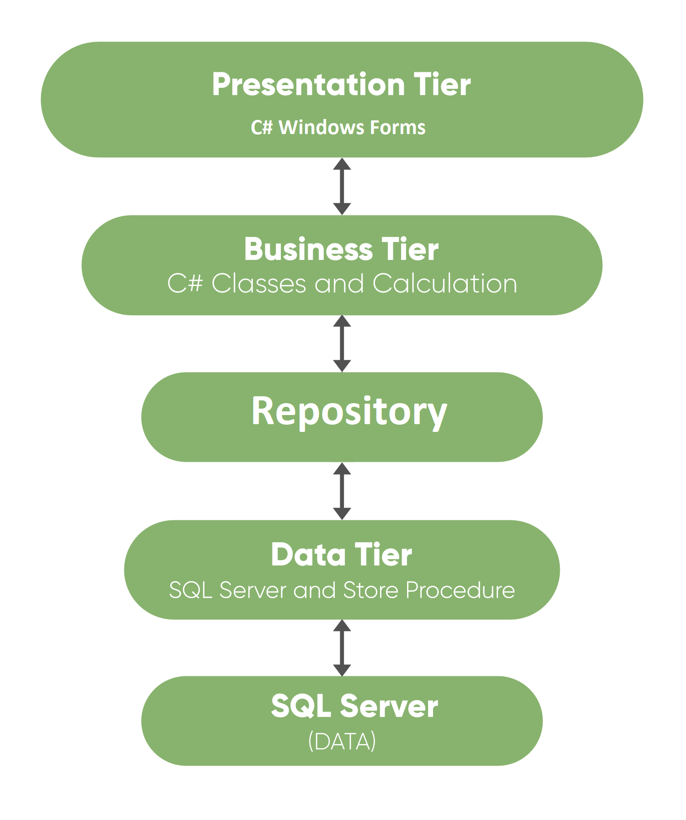

**1.3 Naming Convention**

**t**VariableName -> Temporary variable

**m**VariableName -> Private variable

**p**VariableName -> Parameter variable

**c**VariableName -> Constant variable

**1.4 Presentation Layer (Windows Forms)**

There are 4 main forms:

1. SurveyQuestionConfiguratorForm
2. AddQuestionForm
3. LanguageSettingsForm
4. ConnectionSettingsForm

Every form has 2 languages a user can change from

1. English (default)
2. Arabic

Every Languages has its own resource files to translate messages for both languages named like the following: FormName+”Strings”.resx for English resource files OR FormName+”Strings”.ar-JO.resx for Arabic resource files.

**1.4.1 SurveyQuestionConfiguratorForm**

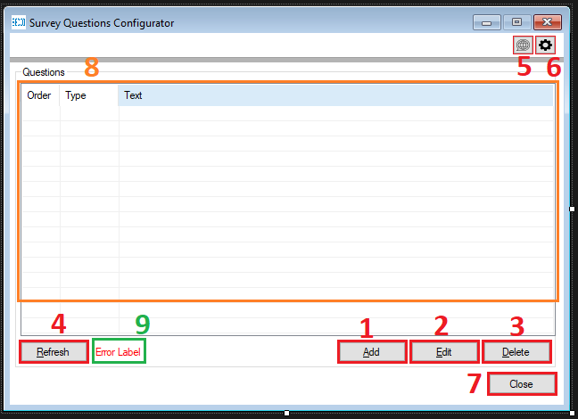

The form has total 9 main controls

1. Add a question.
2. Edit a question.
3. Deleted a question.
4. Refresh the questions list.
5. Change language settings.
6. Change connection settings.
7. Close the application.
8. ListView
9. Label

**Control’s Properties:**

* Form
  1. MinimumSize = MaximumSize = Size
  2. Localizable = True
  3. AutoSize = False
* ListView
  1. FullRowSelect = True
  2. GridLines = True
  3. View = Details
  4. Activation = OnClick
  5. MultiSelect = False

**Code:**

The code is divided into regions based on their functionality.

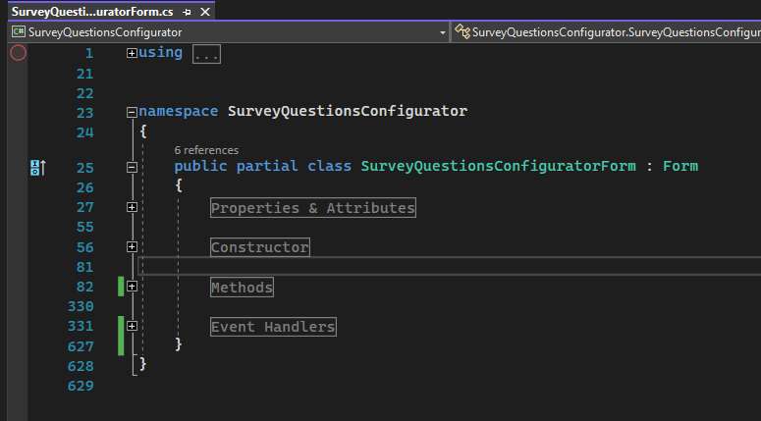

**Properties & Attributes**

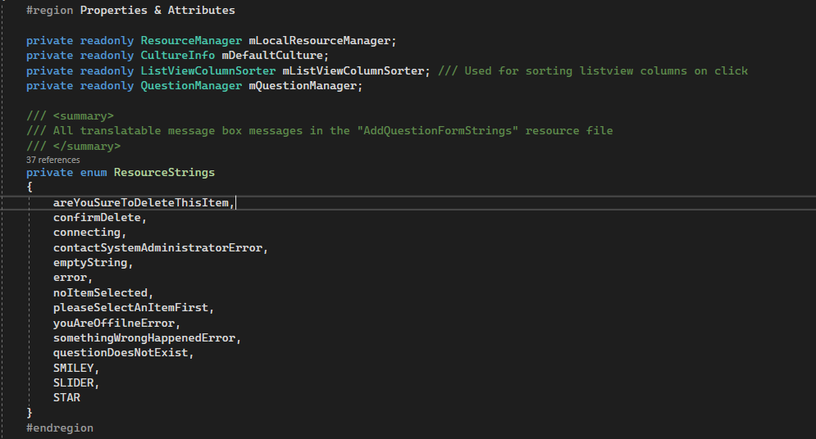

* mLocalResourceManager-> used to access resource files.
* mDefaultCulture-> used to save current CultureInfo (language) of the application [fetched from app.config]
* mListViewColumnSorter-> used to sort ListView’s columns [copy pasted from MS docs]
* mQuestionManager-> object from QuestionManager [Business Logic Layer]
* enum ResourceStrings-> contains all the keys in "AddQuestionFormStrings" resource file which are used for displaying translatable messages

**Constructor**

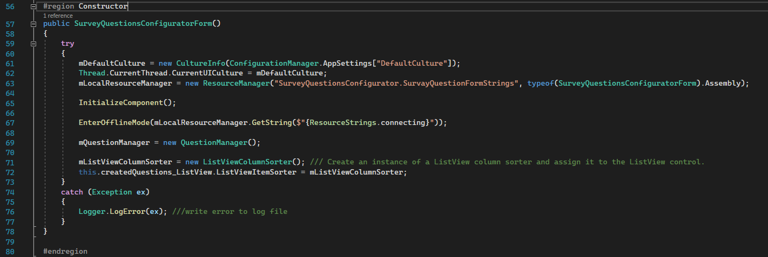

Step 1: gets saved default culture in config file and assign it to current UI culture thread before initializing component

Step 2: Initializes a new instance of the ResourceManager class that looks up resources contained in files with the specified root name in the given assembly.

Step 3: makes the application enter an offline state and display “Connecting…” before connecting and getting data from database.

Step 4: handling listview column click sorting (taken from MS docs)

Step 5: write any error/exception in the log file [located inside a folder named logs under debug folder]

**Methods**

ClearListView

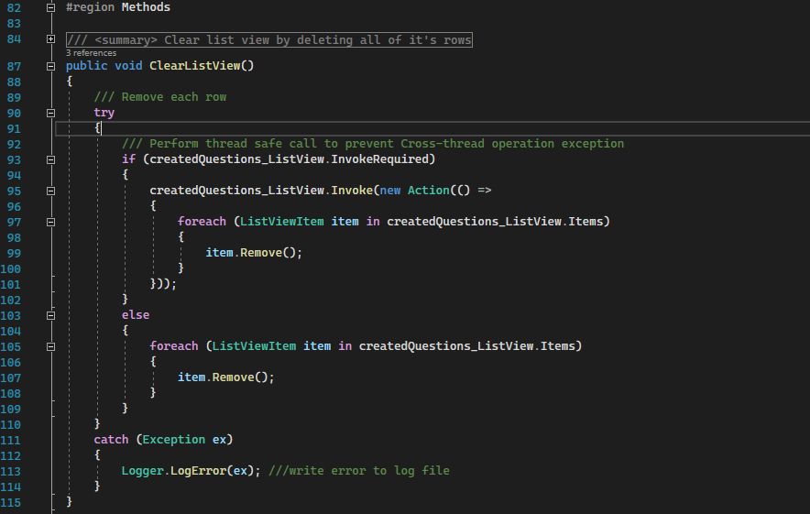

Parameters:  
None.

Description:

This method is used to clear every row in the ListView-> foreach is used instead of .clear() methods because it causes the columns to be deleted too.

Step 1: Check if this control requires invoke, which essentially means check if this control is being modified by another thread (background thread) other than the one it was created on (main or UI thread).

Step 2: Else, you are on the same thread that created it.

Returns:  
void.

BuildListView

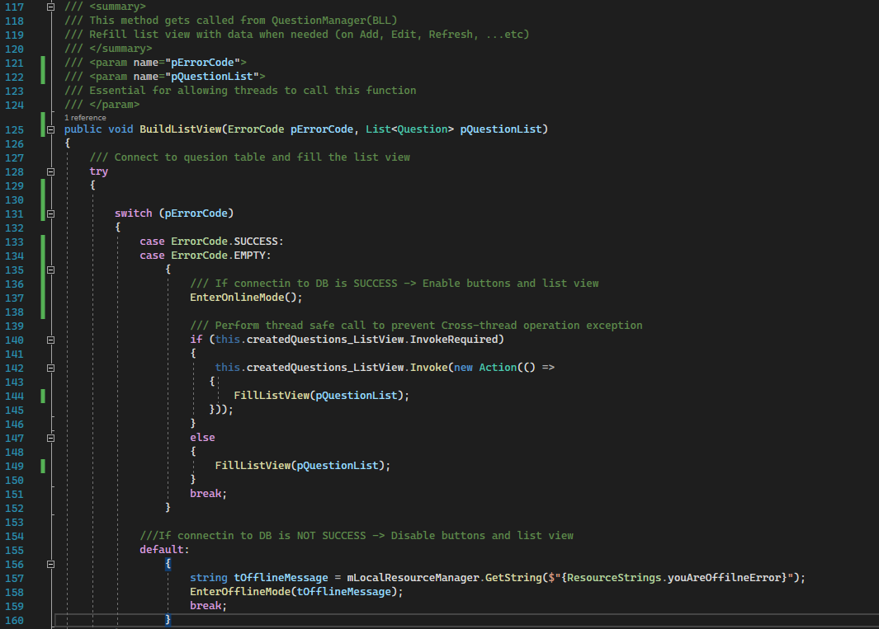

Parameters:  
pErrorCode-> ErrorCode. holds of the state of DB operation was successful, error, etc…

pQuestionList-> List<Question>. holds values return from DB to be viewed in the list

Description:

This method is called from the business logic layer (QuestionManager.cs) and holds all the values that came back from the database (error code and actual values).

Step 1: make the form go into online mode which is making all controls active to the user to interact with.

Step 2: fill the list with actual data.

Step 3: get error message to be shown to the user in the “errorLabel” from the resource manager depending on the current selected language (taken from “DefaultCultrue” section in the app.config file)

Step 4: make the form go into offline mode which is making only the refresh button active and interactive with the user.

Returns:  
void.

FillListView

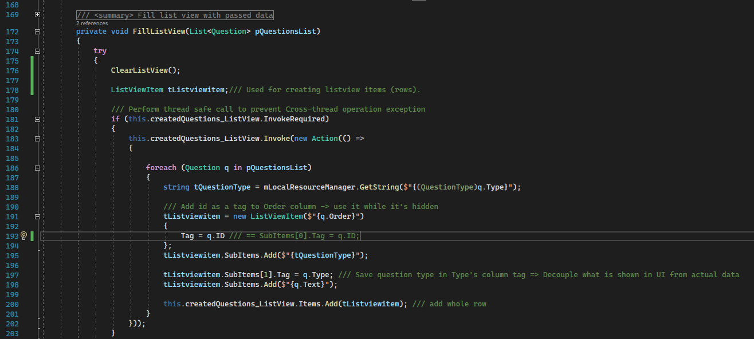

Parameters:

pQuestionList-> List<Question>. list of questions to be rendered to users.

Description:

This method fills the list view with the data passed to it.

Step 1: gets the question type string to be shown in the “Type” column based on the current select language.

Step 2: create new ListViewItem with the first element to be show is the order of the question.

Step 3: Save the ID of the question in its “Tag” property so it is not shown to the user but it’s still used in the DB operations.

Step 4: save the type of the question in the “Tag” property because it is different than what is shown in the list view so it can’t be taken directly from it and do DB operations with it.

Step 5: add the row that was just created to the list view.

Returns:

Void.

EnterOfflineMode

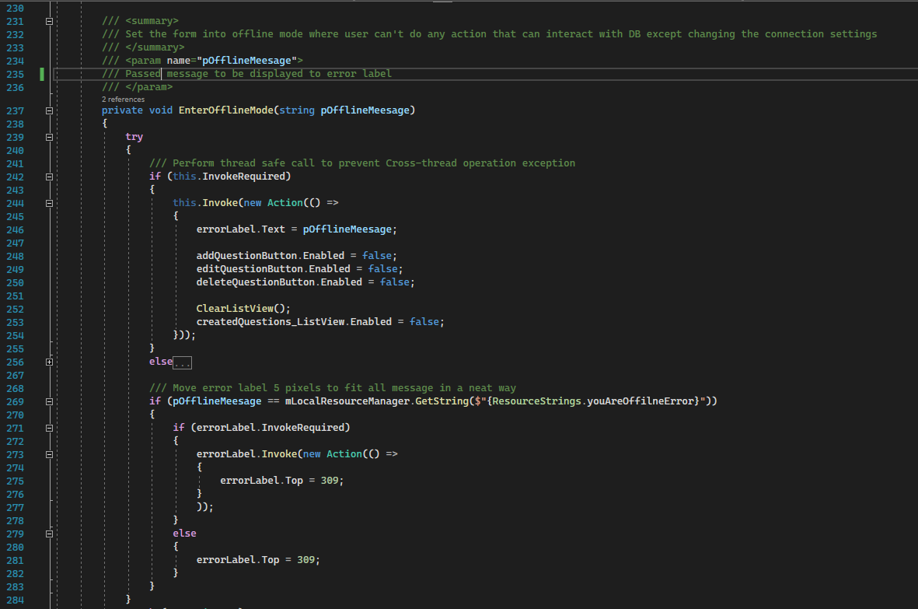

Parameters:

pOfflineMeesage-> string. message to be displayed to the user in the error label

Description:

Step 1: checks if the form needs to be invoked and changed multiple controls at once.

Step 2: move the label 5 pixels to the top so it can fit the long offline error message with a nice UI.

Returns:  
void.

EnterOnlineMode

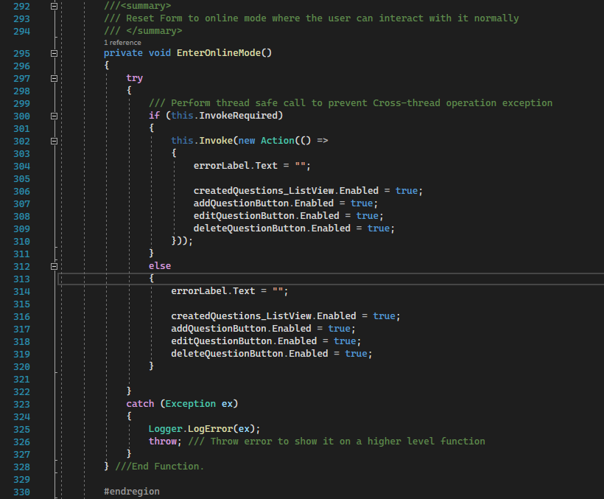

Parameters:

None.

Description:

Returns all controls enabled back.

Returns:

None.

**Event Handlers:**

SurveyQuestionsConfiguratorForm_Load:

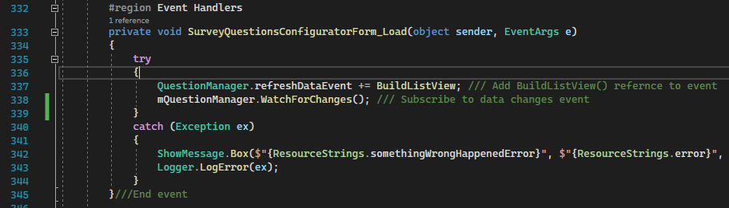

Description:

This event handler adds BuildListView reference to the event that calls this function when DB “Questions” table changes and subscribes to this event by calling WatchForChanges() function.

createdQuestions_ListView_ColumnClick

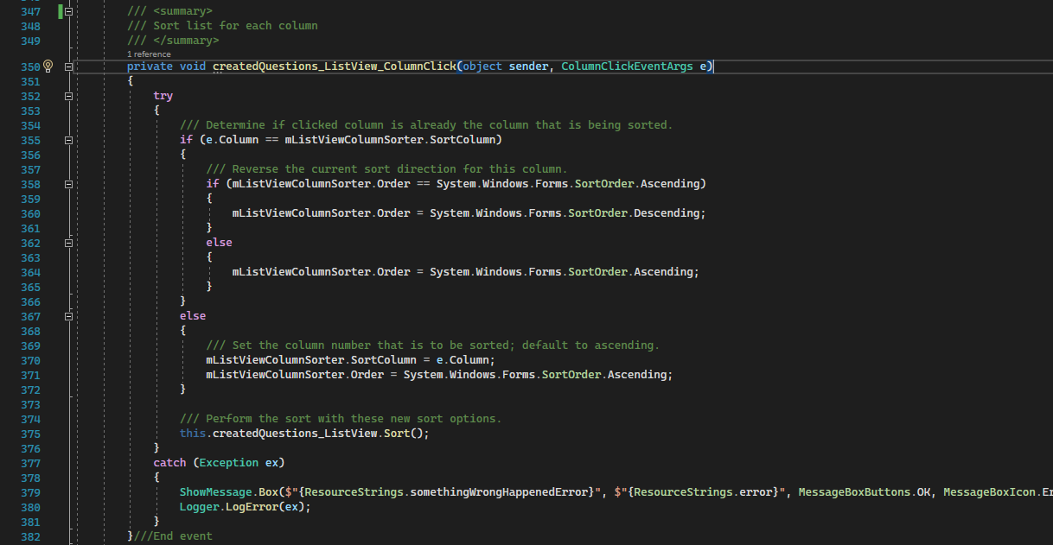

Description:

Sorts ListView’s columns based on each column values.

This code was taken from [MS docs](https://docs.microsoft.com/en-us/troubleshoot/developer/visualstudio/csharp/language-compilers/sort-listview-by-column).

addQuestionButton_Click

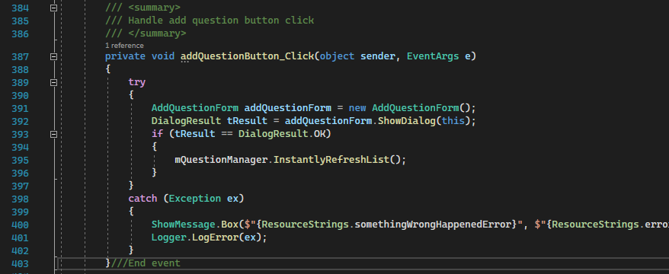

Description:

This event handler handles opening up new form for adding a question to the question list.

Step 1: if the add operation was successful the list will be refresh instantly to show the new added question to the user.

deleteQuestionButton_Click

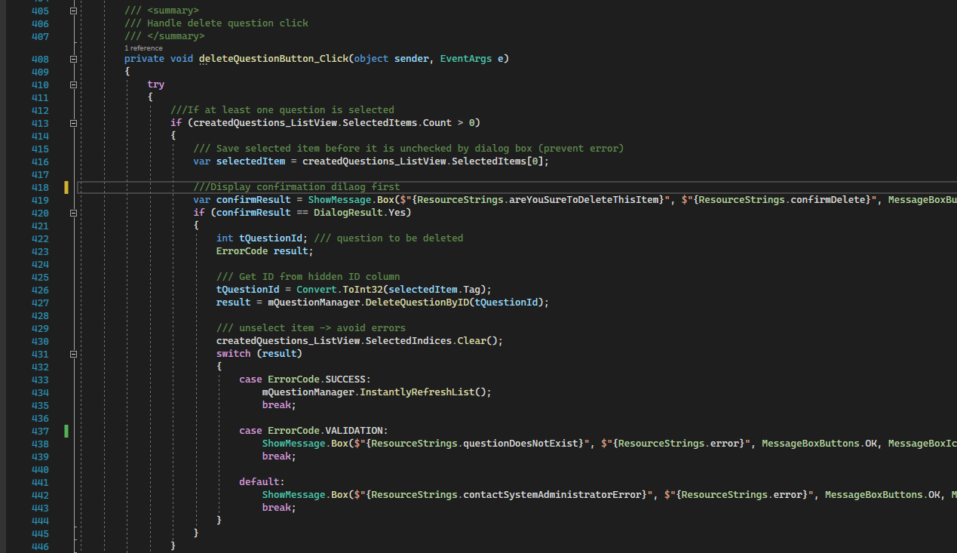

Description:

This event handler checks at first if there is any row selected to be deleted or not and save it to a variable.

Then displays a confirmation message box dialog to confirm the deletion process from the user.

If the user selected “Yes”-> try to delete question from the DB and do some action based on the returned result, either refresh the list or display a corresponding message to the user.

refreshDataButton_Click

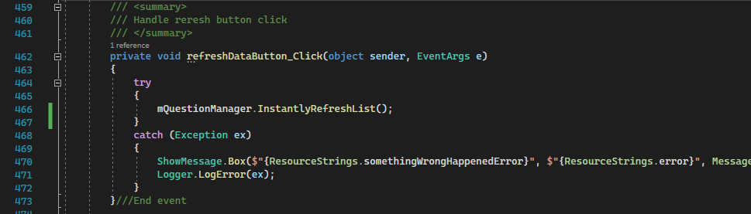

Description:

This event handler handles the refresh button click event which is calling the method that invokes BuildListView method that is subscribed to it.

editQuestionButton_Click

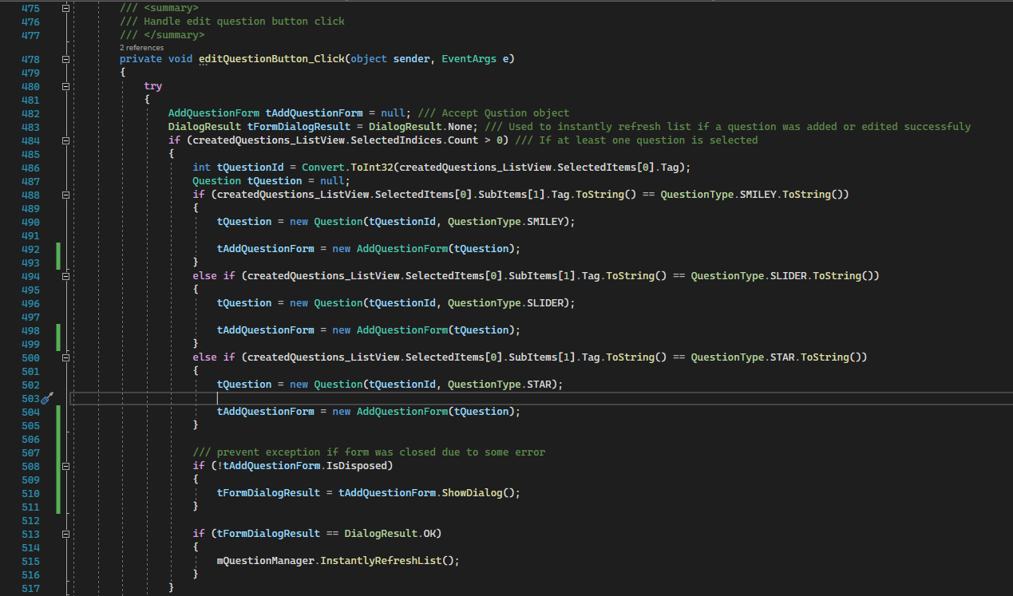

Description:

This event handler handle **2 events**:

1. Edit button click
2. And ListView’s row double click

This method checks if an item was selected before editing it, then checks the type of the selected question and based on it creates a new question with the ID and Type of question. And pass it to the form’s constructor that is use to also adding a question.

But in this case the form knows it is editing a question not adding one.

connectionSettingsButton_Click

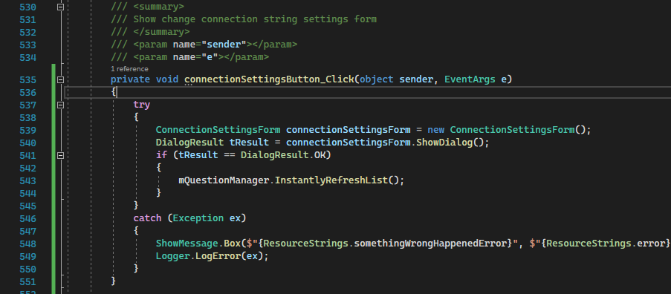

Description:

This event handler handle showing the form which handles changing the connection string settings.

closeApplicationButton_Click

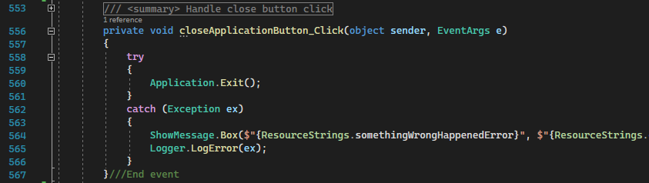

Description:

This event handler handle closing the application.

languageSettingsButton_Click

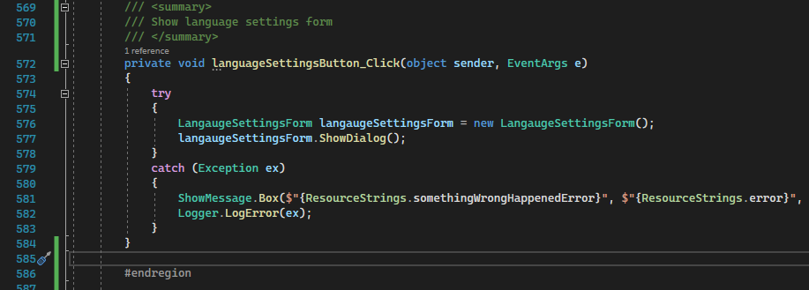

Description:

This event handler handle showing change language form.

**1.4.2 AddQuestionForm**

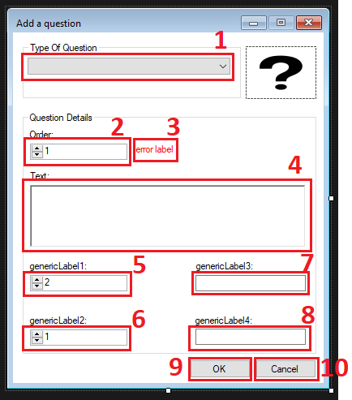

The form has total 10 main controls

1. Combo box.
2. questionOrderNumericUpDown.
3. Error label.
4. questionTextRichTextBox.
5. genericNumericUpDown1.
6. genericNumericUpDown2.
7. genericTextBox1.
8. genericTextBox2.
9. Ok/save button
10. Cancel button

**Controls Properties:**

* Combobox:
  + DropDownStyle-> DropDownList
* Order numeric up down
  + Maximum-> 9999999
* Rich box
  + MaxLength-> 3999
* genericNumericUpDown1
  + Minimun->1
  + Maximum->100
* genericNumericUpDown2
  + Minimun->1
  + Maximum->100
* genericTextBox1
  + MaxLength->99
* genericTextBox2
  + MaxLength->99

**Code:**

The code is divided into regions based on their functionality.

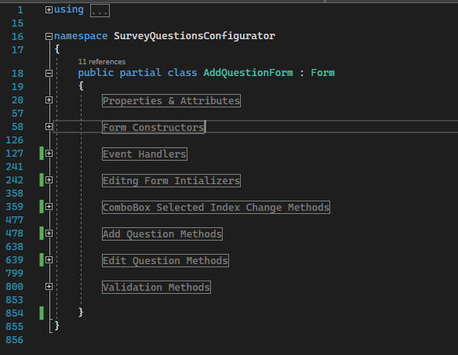

**Properties & Attributes**

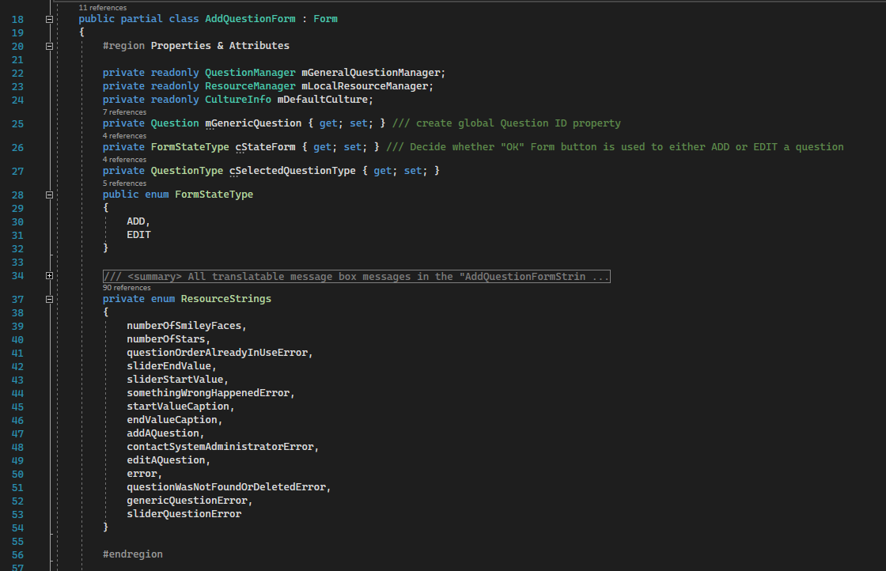

Step 1: instance of QuestionManager (Business logic layer).

Step 2: Generic question to be used in multiple methods/event handles.

Step 3: save the setting of which the form is adding or editing.

Step 4: save the type of the current question.

**Form Constructors**

AddQuestionForm

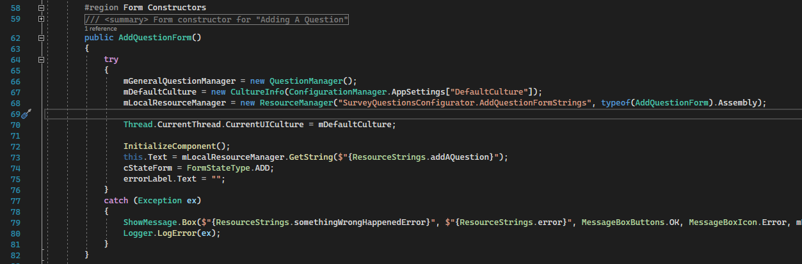

Description:

Initialize the form for adding a question

AddQuestionForm(Question pQuestion):

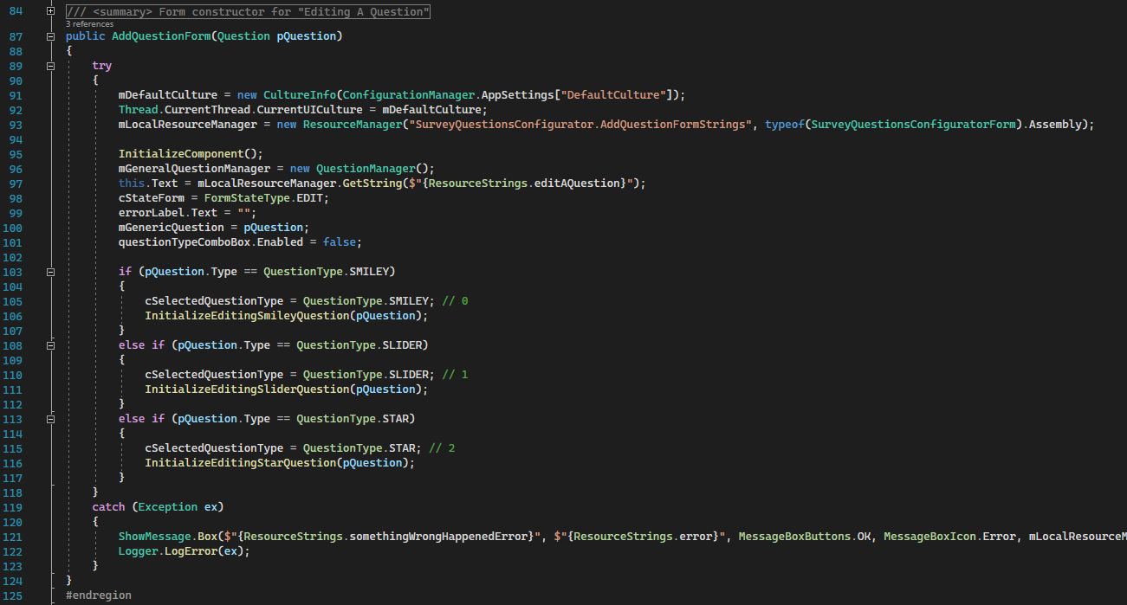

Description:

Initialize the form for editing a selected question

Step 1: disable changing current edited question type.

Step 2: Load the settings of the passed question based on its ID and Type

**Event Handlers**

AddQuestionForm_Load

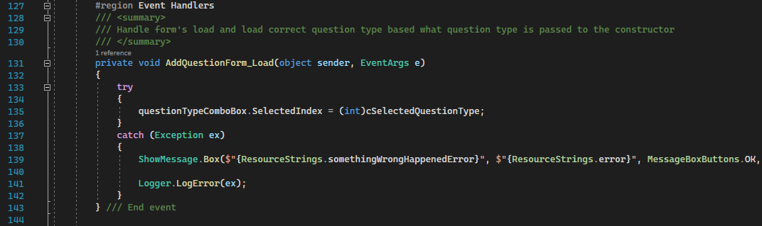

Description:

Sets combo box selected index

cancelButton_Click

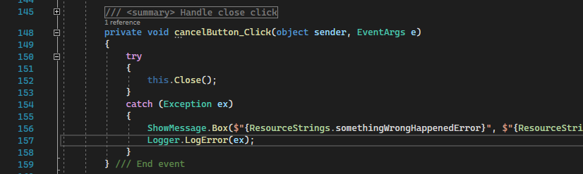

Description:

Close the application

okButton_Click

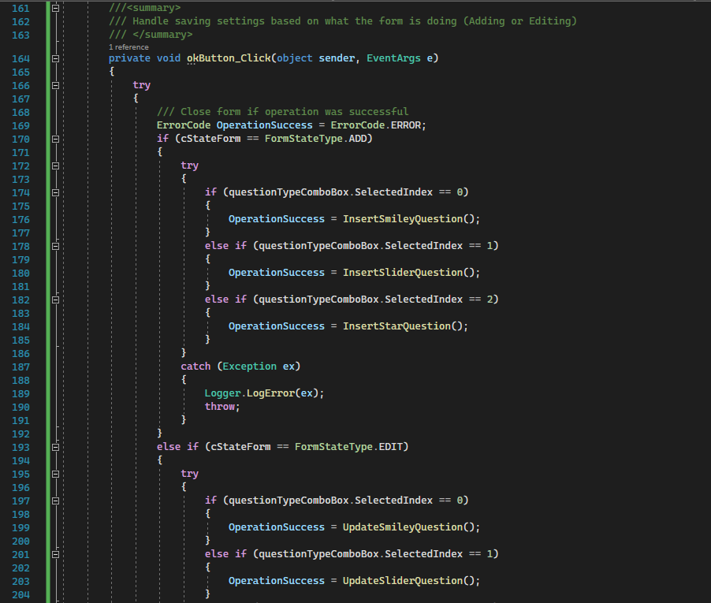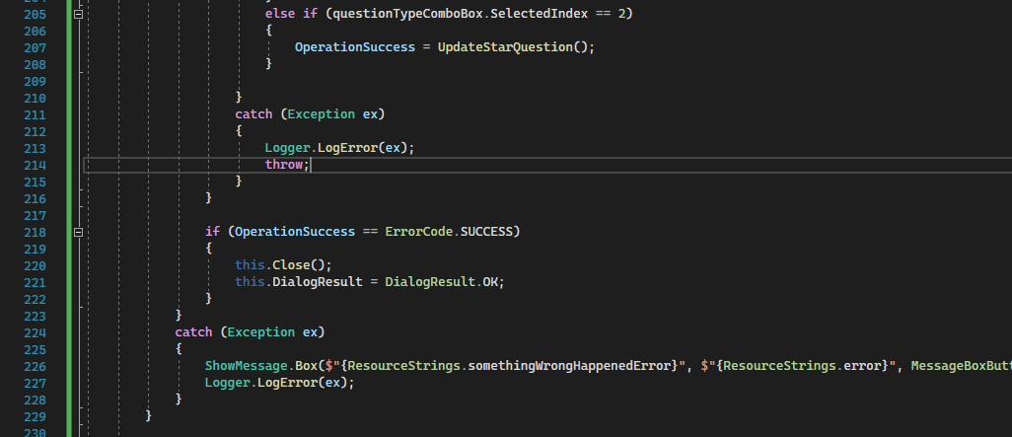

Description:

If cStateForm = Add, it attempts a DB insert operation

If cStateForm = Edit, it attempts DB update operation

And saved the operation result on in a variable.

If it was successful-> close the form and return OK as dialog result to the parent form

**Editng Form Intializers**

LoadSmileyQuestion, LoadSliderQuestion & LoadStarQuestion

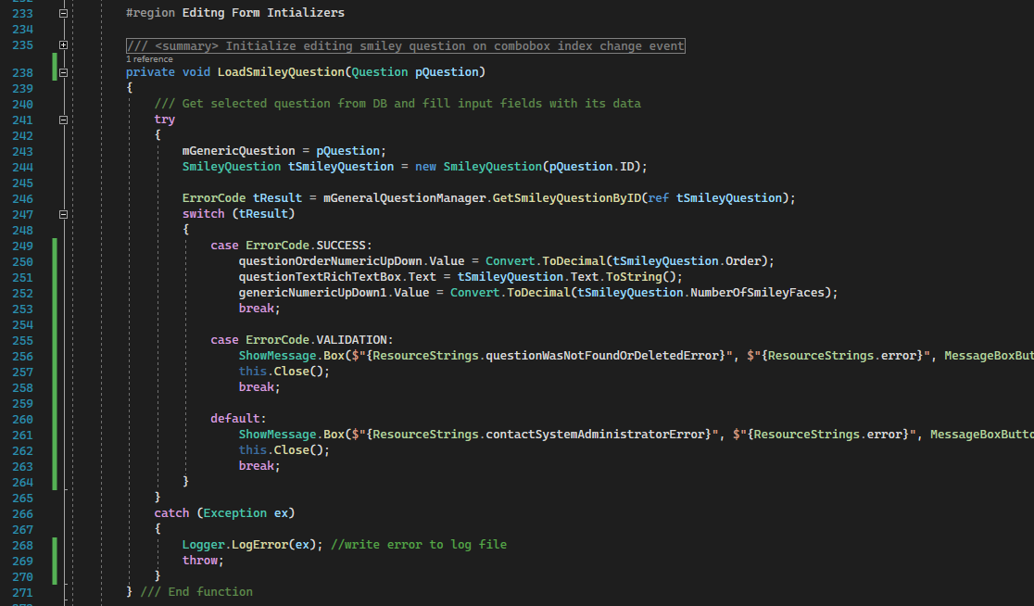

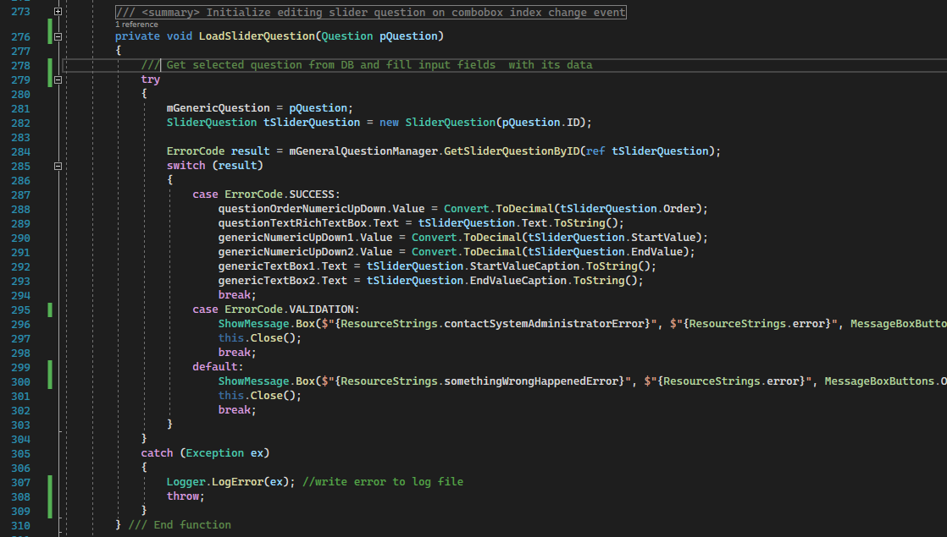 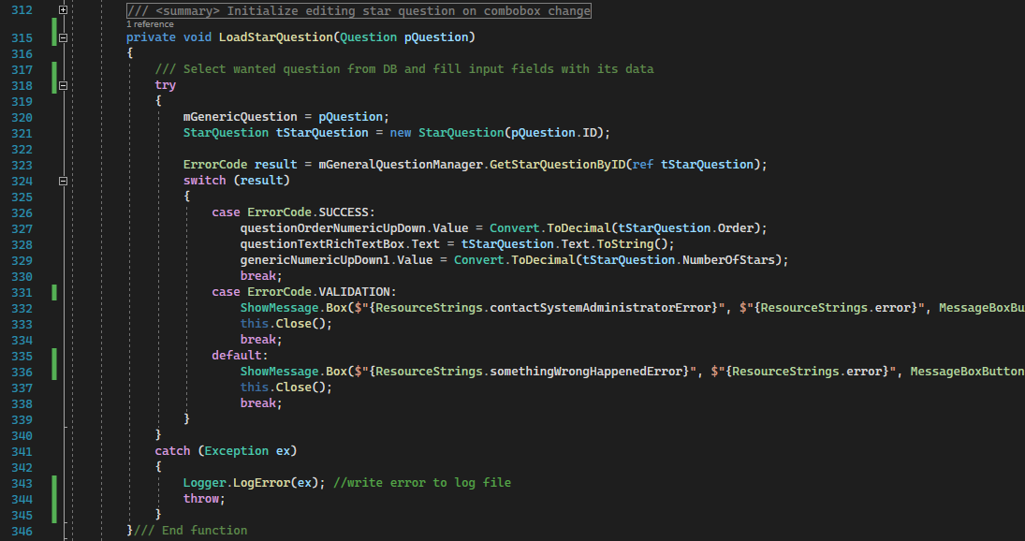

Desctiption:

All of three methods load question details to be editied and fill the appropriate controls with data.

**ComboBox Selected Index Change Methods**

questionTypeComboBox_SelectedIndexChanged

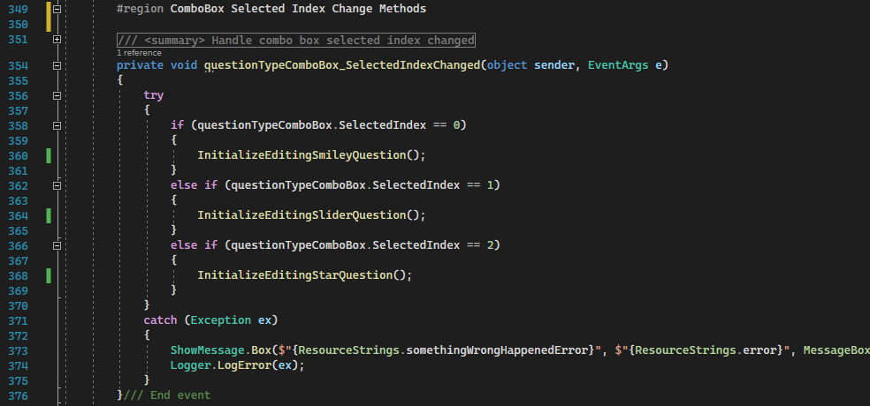

Description:

Change the form visible controls and label’s text based on what question the user want to add.

**Add Question Methods**

InsertSmileyQuestion, InsertSliderQuestion & InsertStarQuestion

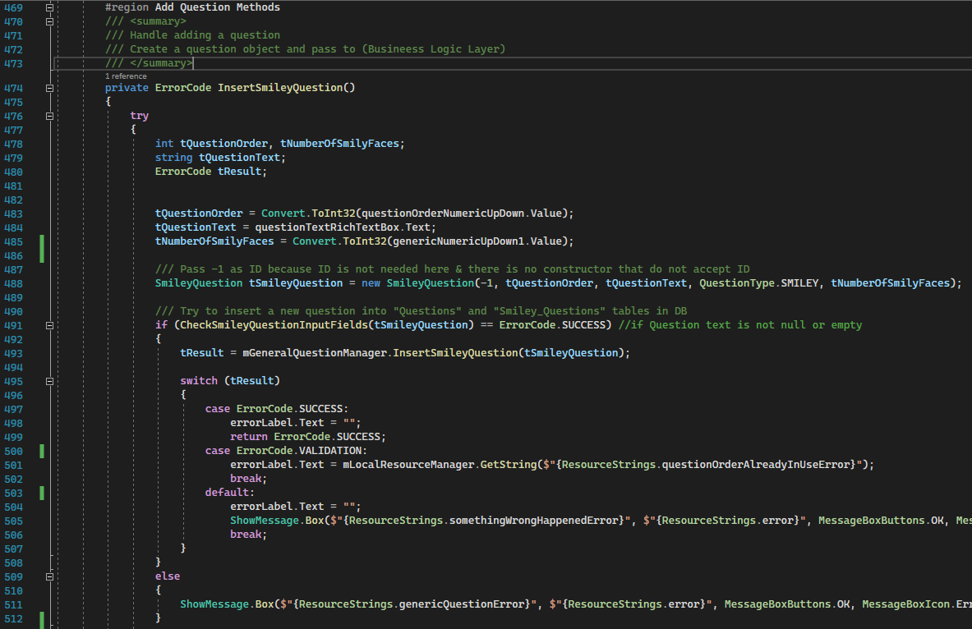

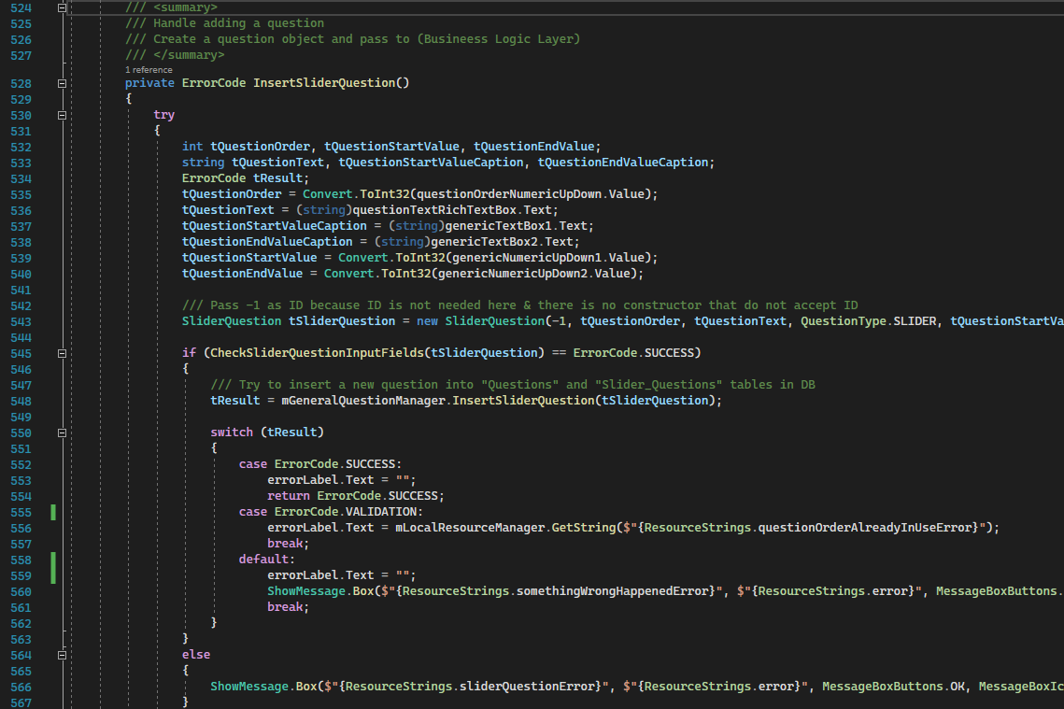

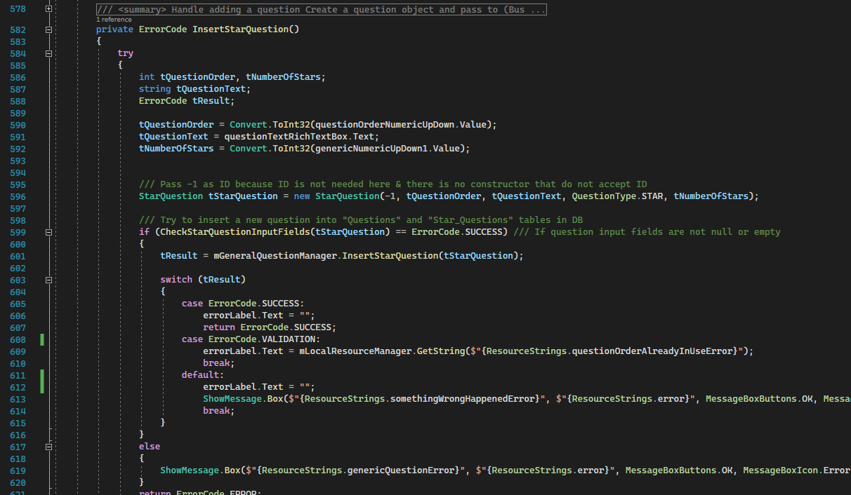

Description:

These methods get data from controls.

And create a corresponding question object with ID = -1.

Then check if the values are valid and pass it to BLL and try to insert it in the database.

Returns:  
ErrorCode based on the operation.

**Edit Question Methods**

UpdateSmileyQuestion, UpdateSliderQuestion & UpdateStarQuestion:

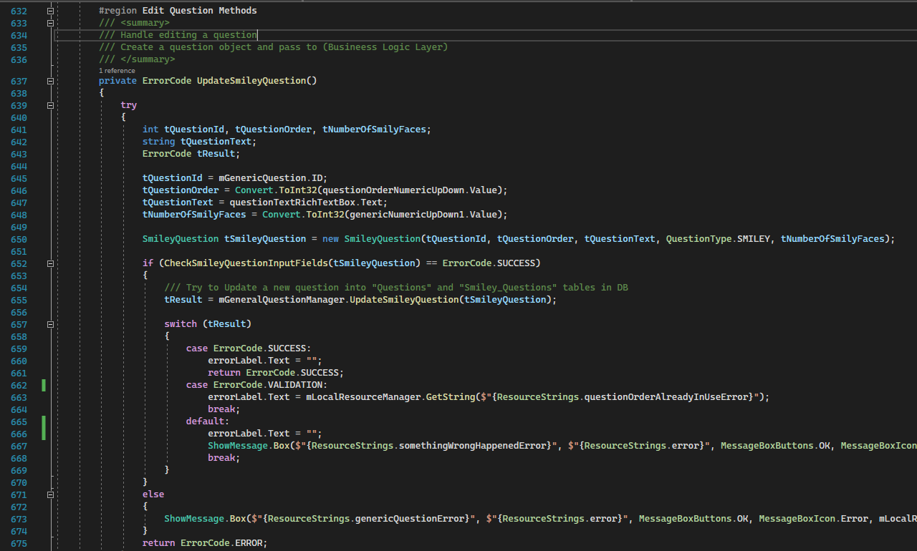

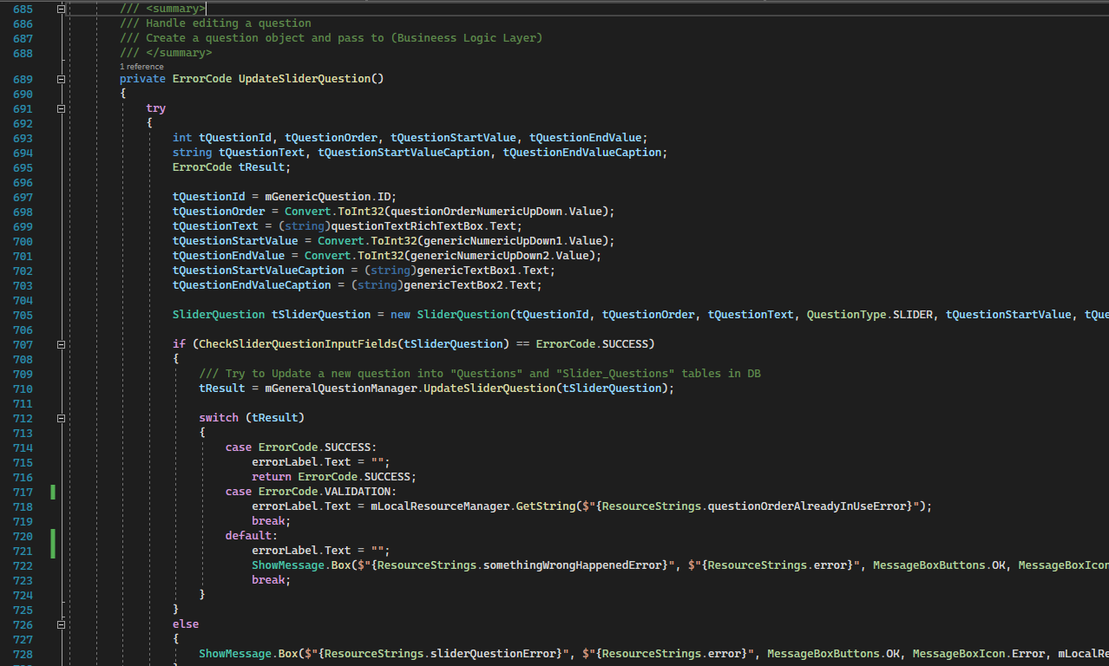

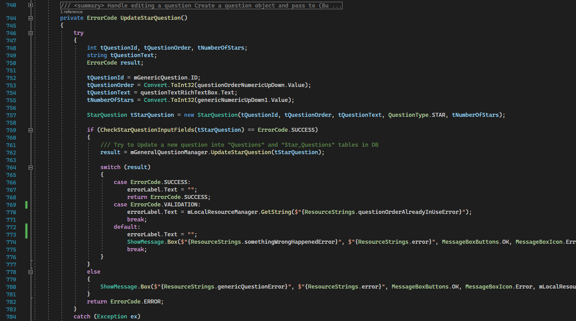

Description:

These methods get data from controls.

And create a corresponding question object with the appropriate ID.

Then check if the values are valid and pass it to BLL and try to update it in the database.

Returns:  
ErrorCode based on the operation.

**Validation Methods**

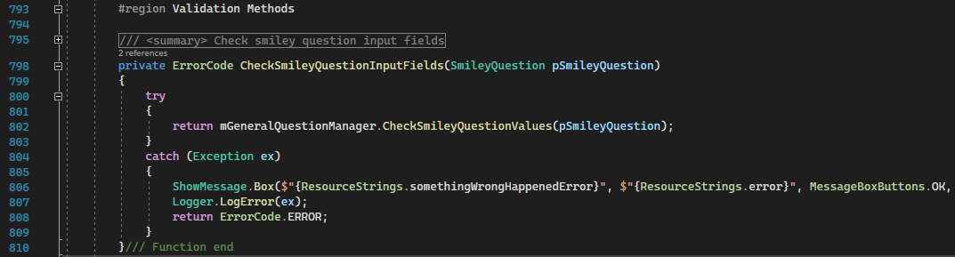

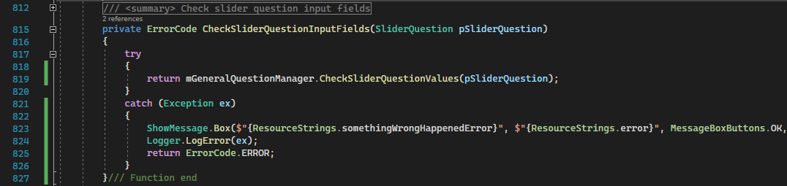

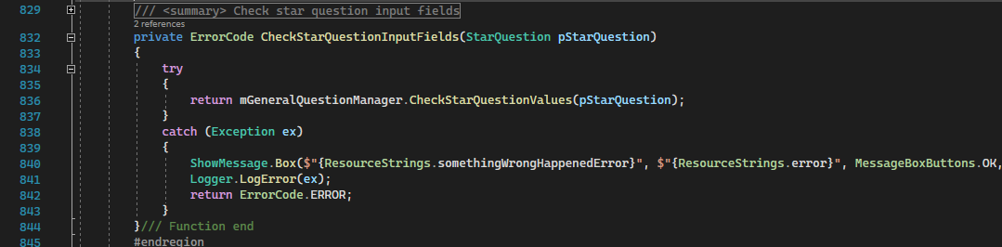

Description:

Check the fields and input of each question type.

Returns:  
ErrorCode based if the data are valid or not.

**1.4.3 ConnectionSettingsForm**

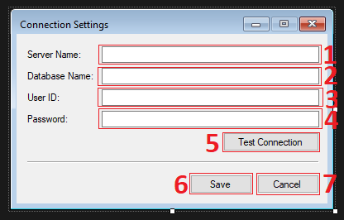

The form has total 7 main controls

1. Server name text box.
2. Database name text box.
3. User ID text box.
4. Password text box.
5. Test connection button.
6. Save settings button.
7. Cancel button.

**Control’s Properties:**

All text boxes have MaxLength = 128

**Code:**

The code is divided into regions based on their functionality.

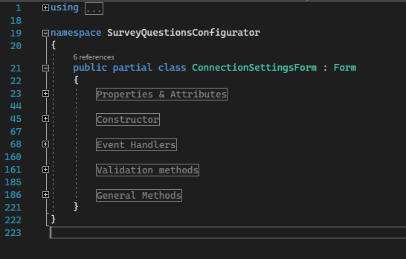

**Properties & Attributes**

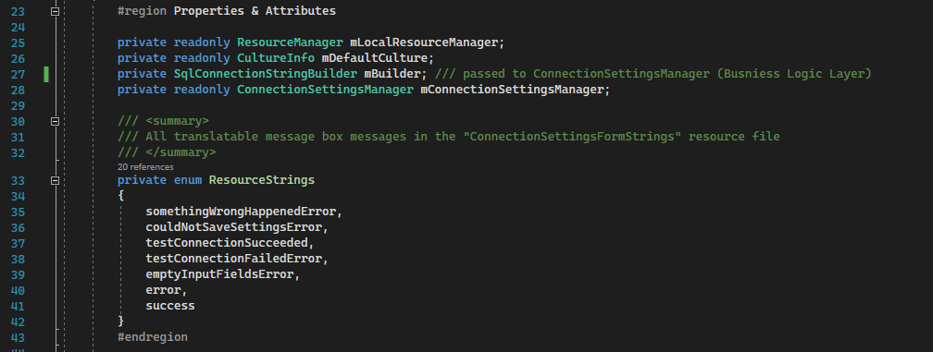

**Constructor**

ConnectionSettingsForm

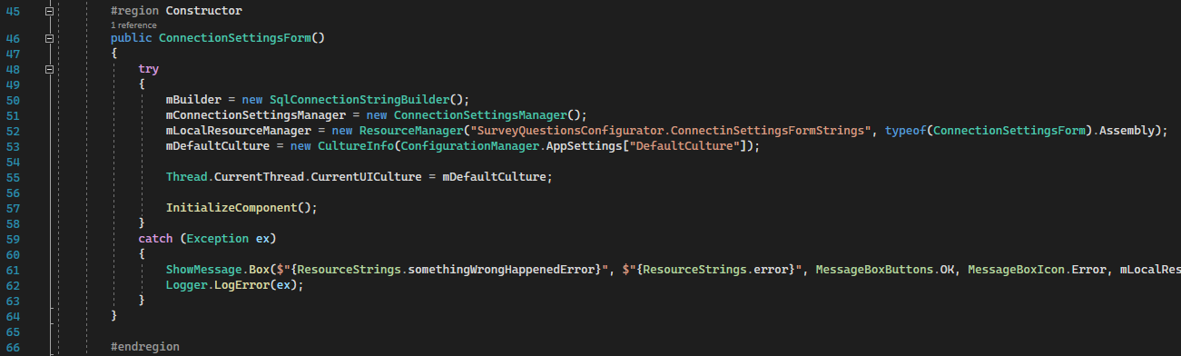

Step 1: Gets the default UI culture from config file and sets it to the current thread’s CurrentUICulture property

**Event Handlers**

ConnectionSettingsForm_Load:

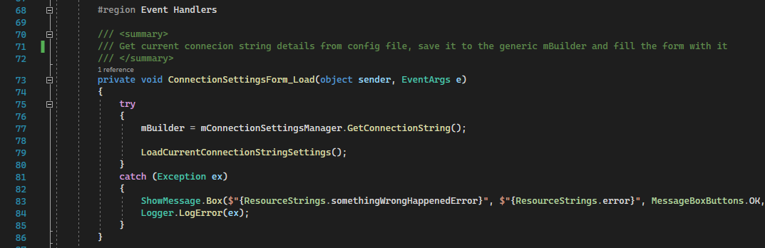

Description:

Get current connecion string details from config file, save it to the generic mBuilder and fill the form with it

cancelButton_Click:

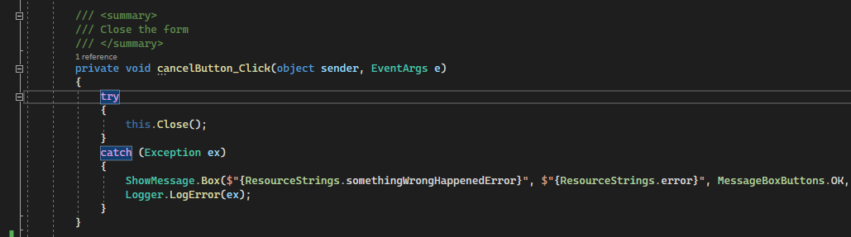

Description:

Closes the form

testConnectionButton_Click:

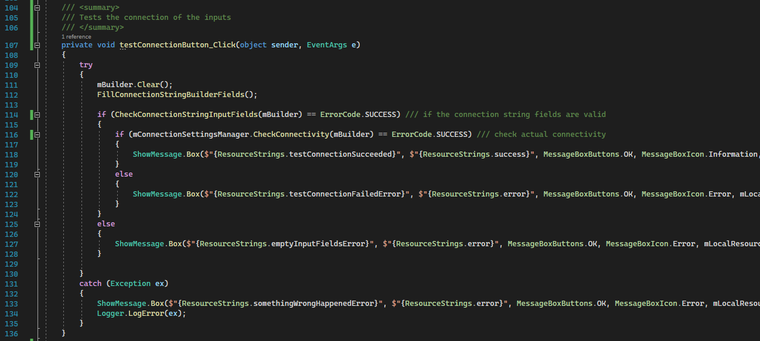

Description:

Fill the mBuilder with corresponding inputs and text them

saveButton_Click

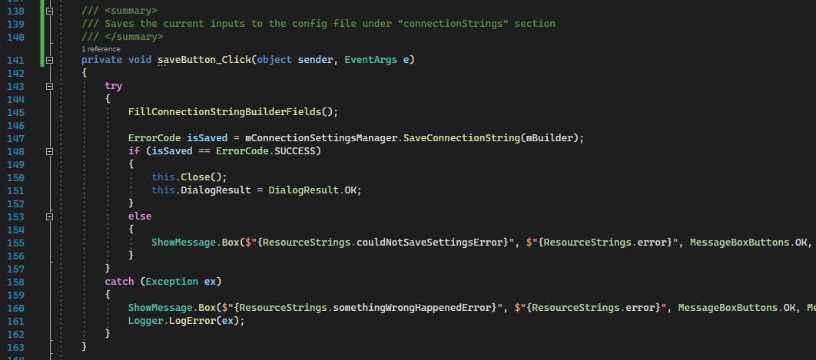

Description:

Fill the mBuilder save its fields to the config file.

**Validation methods**

CheckConnectionStringInputFields:

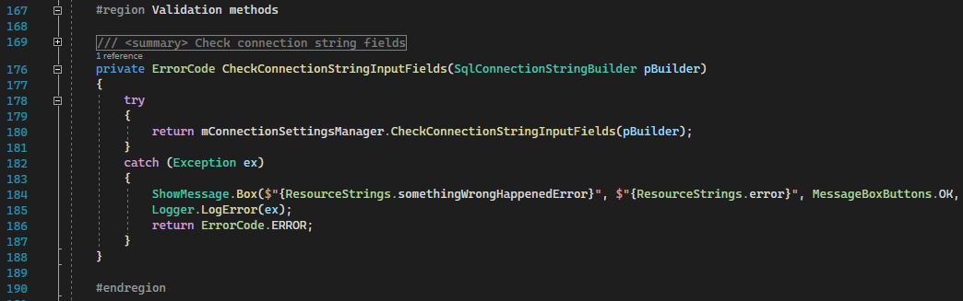

Description:

Check the fields in of the mBuilder in the Business Logic Layer

Returns:  
ErrorCode

**General Methods**

FillConnectionStringBuilderFields:

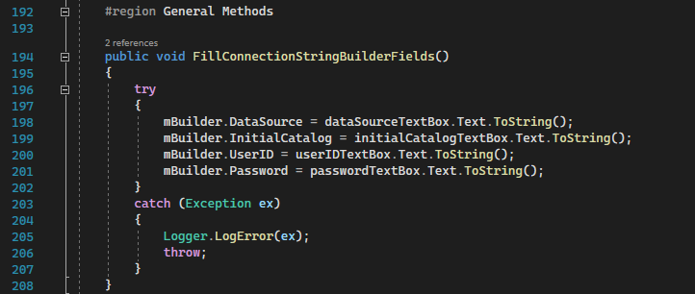

Description:

Fill mBuilder with corresponding text boxes values.

FillConnectionStringBuilderFields:

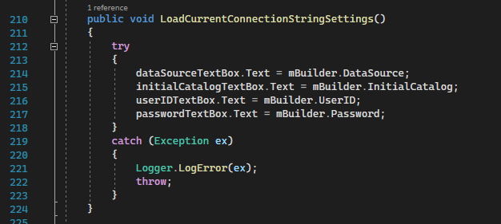

Description:

Fill input text boxes with corresponding data from mBuilder.

**1.4.4 LangaugeSettingsForm**

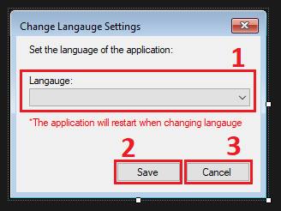

The form has total 3 main controls

1. Language combo box.
2. Save button.
3. Cancel button.

**Control’s Properties:**

* languageComboBox
  + DropDownStyle-> DropDownList

**Code:**

The code is divided into regions based on their functionality.

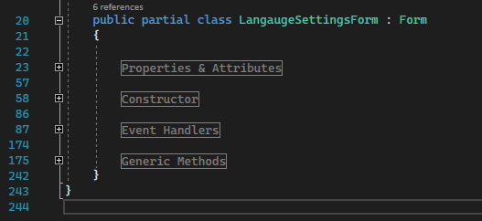

**Properties & Attributes**

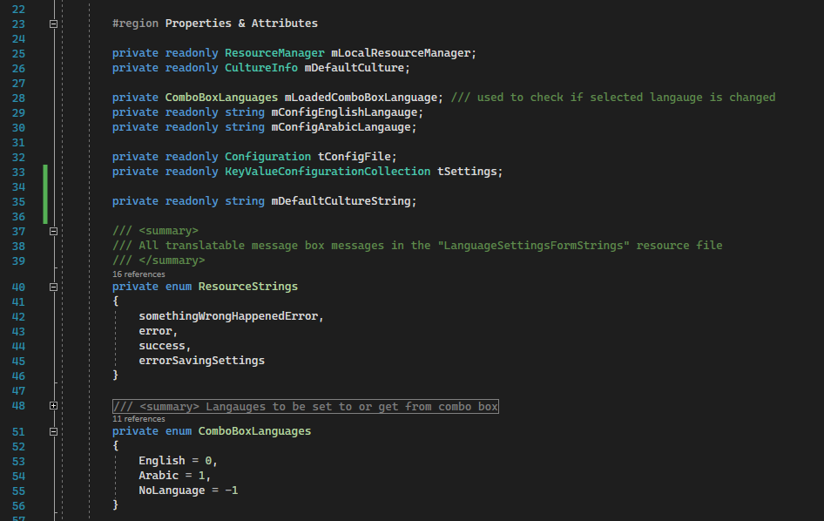

Step 1: saves loaded language settings.

Step 2: access config file.

Step 3: xml attribute to be saved.

**Constructor**

LangaugeSettingsForm:

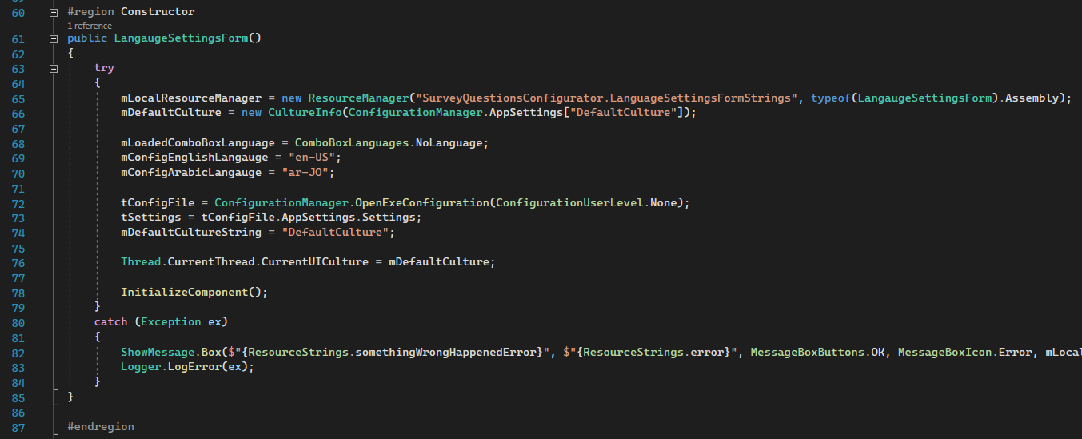

Setup the form’s controls and strings to be used later.

**Event Handlers**

cancelButton_Click

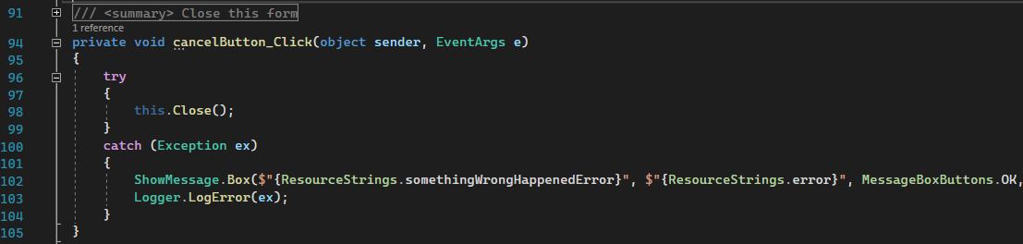

Description:

This event handler closes the form

LangaugeSettingsForm_Load

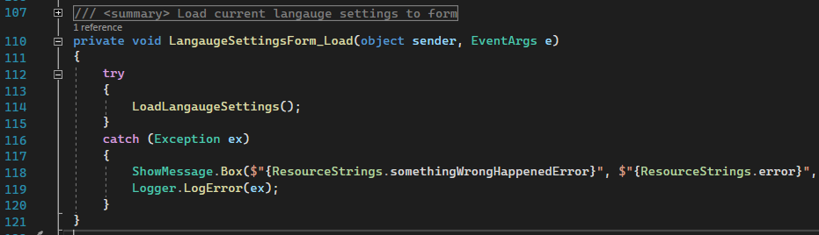

Description:

This event handler load saved language settings to the form (language combo box)

saveButton_Click:

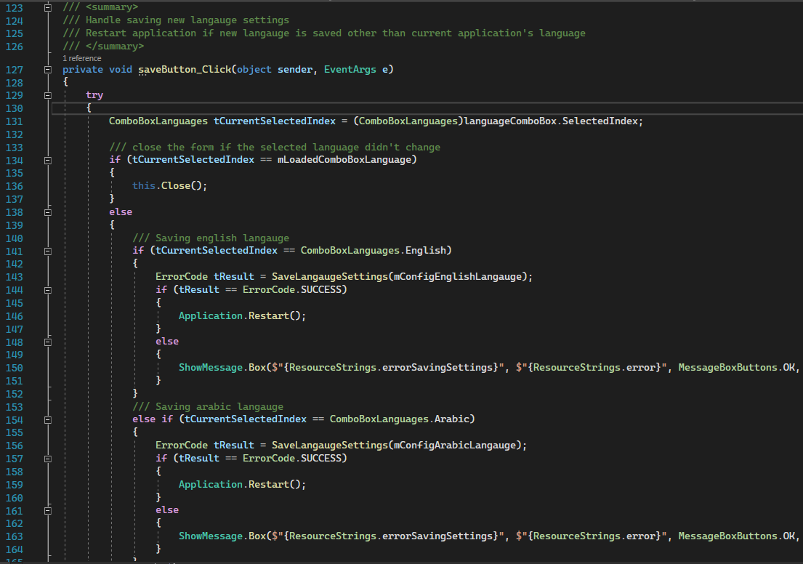

Description:

This event handler handles saving new language settings.

If settings didn’t change the form will close.

If settings changed, new settings will be saved and the application will restart to reflect the new language.

LoadLangaugeSettings

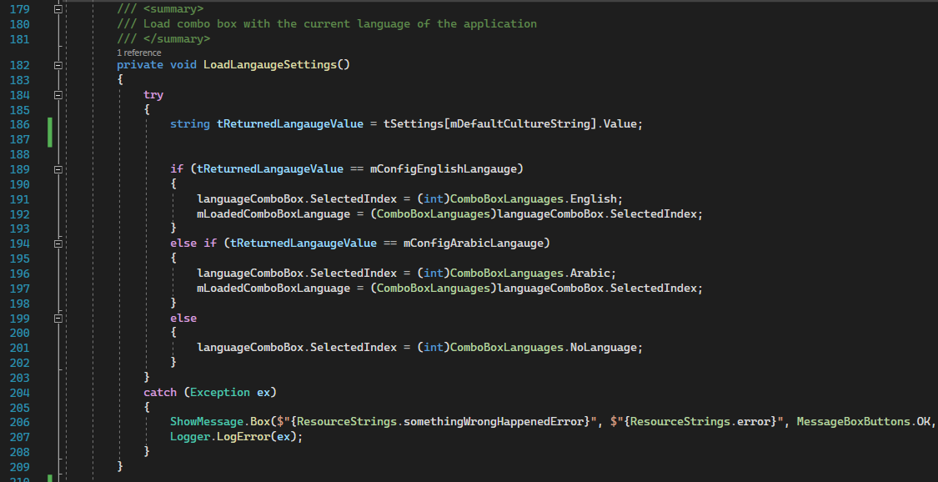

Description:

This method load the combo box with saved language settings

SaveLangaugeSettings

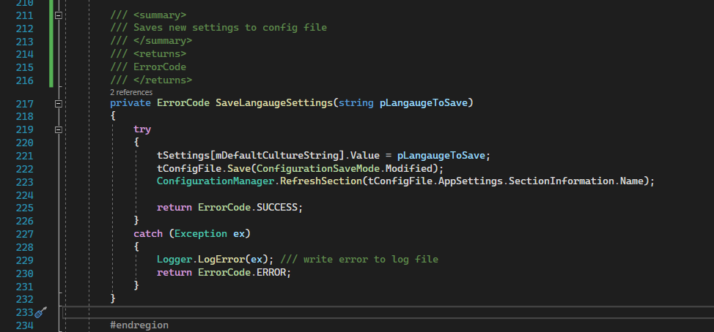

Description:

Saves new settings to config file

Returns:  
ErrorCode

**1.4.5 ShowMessage class**

This class contains a method that is responsible for showing MessageBoxes

Box method:

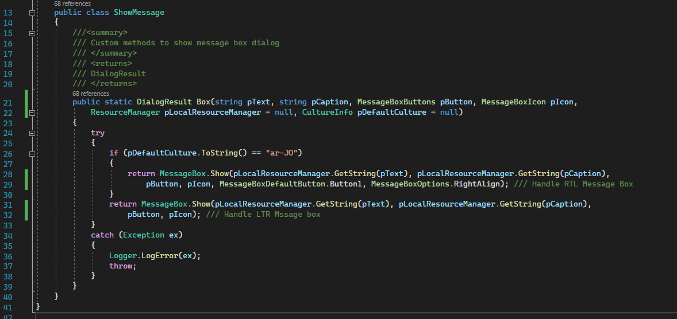

Parameters:

pText-> string

pCaption-> string

pButton-> MessageBoxButtons

pIcon-> MessageBoxIcon

pLocalResourceManager = null-> ResourceManager

pDefaultCulture = null-> CultureInfo

Description:

This function receives normal message box parameters with ResourceManager and CultrueInfo to handle the language and the translation of messages that appear on the message box.

Step 1: shows a messages box that handles RTL languages

Step 2: shows a normal LTR message box

Returns:

DialgoResult

**1.5 Business Logic Layer**

**1.5.1 QuestionManager**

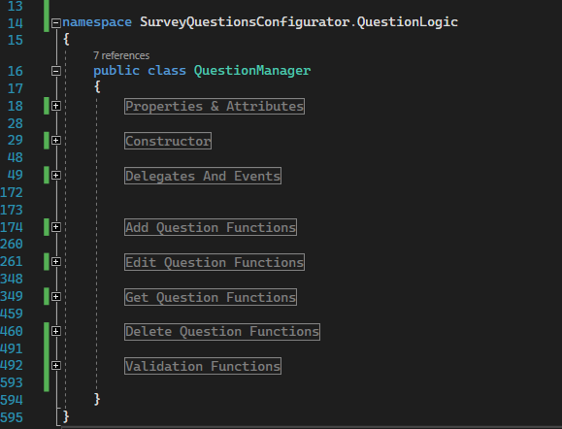

**Properties & Attributes**

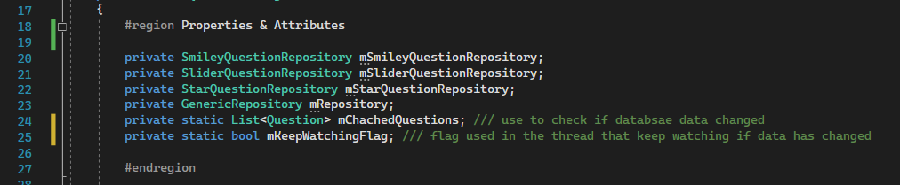

Step 1: create instances of every question repository.

Step 2: use to check if database data changed

Step 3: flag used in the thread that keep watching if data has changed

**Constructor**

QuestionManager

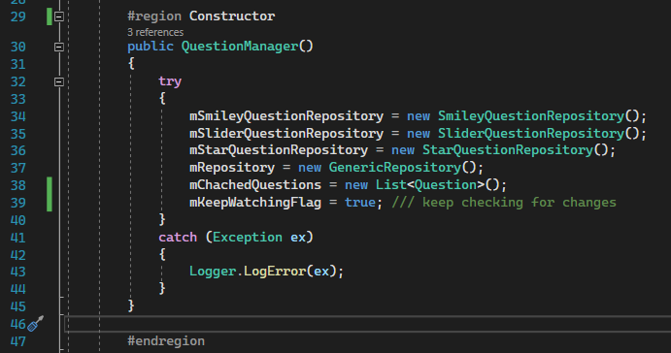

Step 1: set flag to true-> keep checking for changes.

**Delegates And Events**

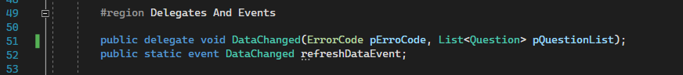

Step 1: create delegate that holds reference of functions that wants to subscribe for it.

Step 2: create event for that delegate.

WatchForChanges:

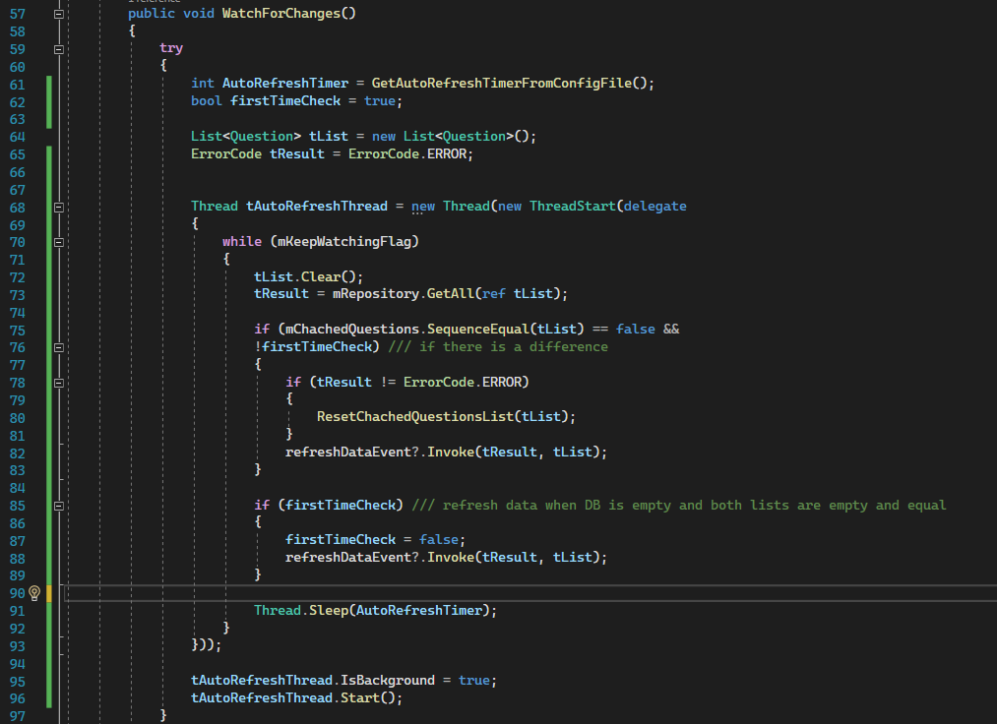

Description:

Create a thread that continuously watch for changes in the database and compare them to the chanced list and invoke referenced function then sleeps again.

Step 1: check if it is first time launch of the application and the DB is empty

Step 2: get data regardless then sets flag to false

Sleep time is fetched from config file.

InstantlyRefreshList 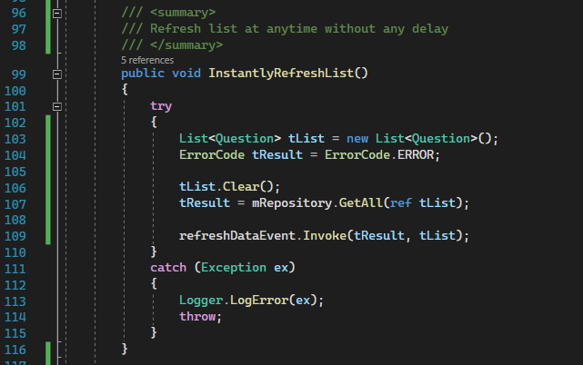

Description:

This function invokes event without any condition.

StopWatching

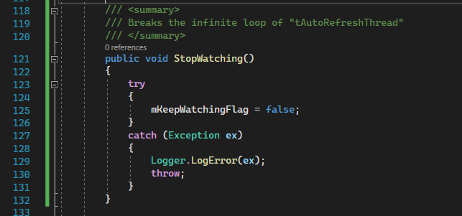

Description:

Breaks the infinite loop of WatchForChanges() method’s thread

GetAutoRefreshTimerFromConfigFile

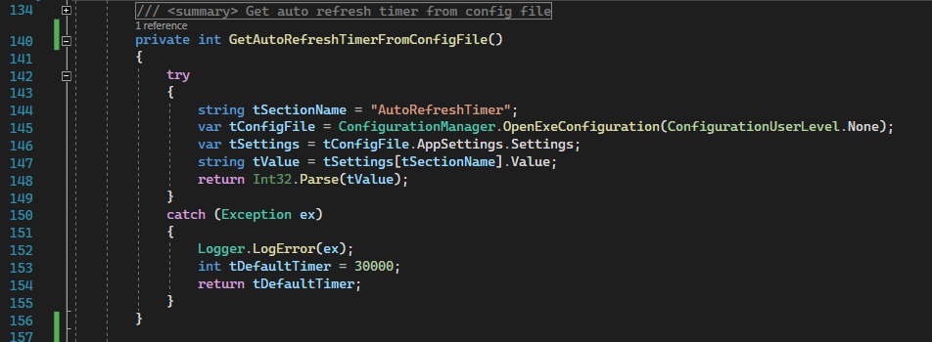

Description:

Gets and return auto refresh timer from config file

ResetChachedQuestionsList

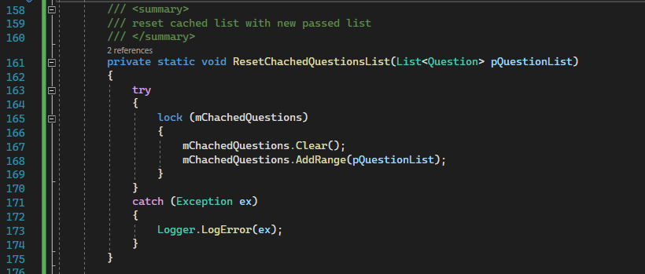

Description:

Reset cached list with new passed list and lock the resetting process so one single thread at a time can access it.

InsertSmileyQuestion, InsertSliderQuestion & InsertStarQuestion

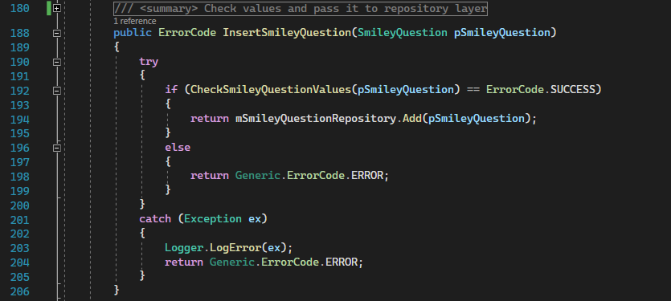

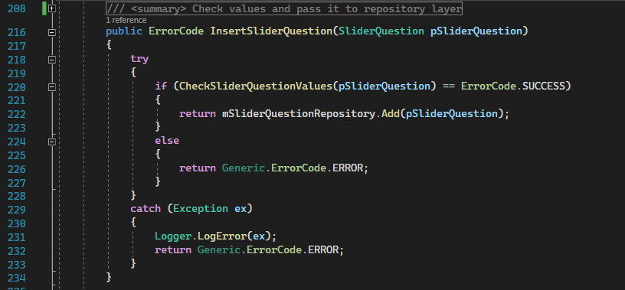

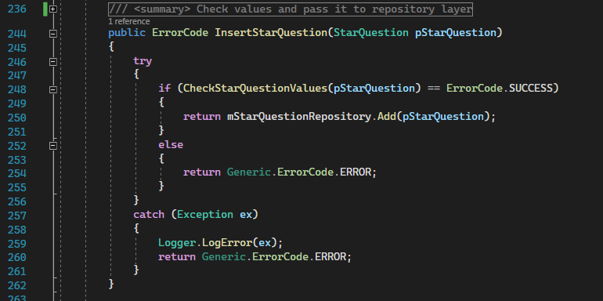

Description:

All of these methods validate their corresponding passed question and pass them to their corresponding repository layer.

UpdateSmileyQuestion, UpdateSliderQuestion & UpdateStarQuestion

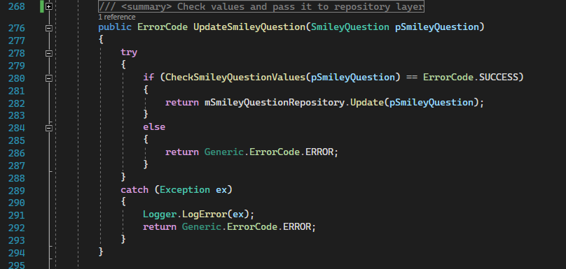

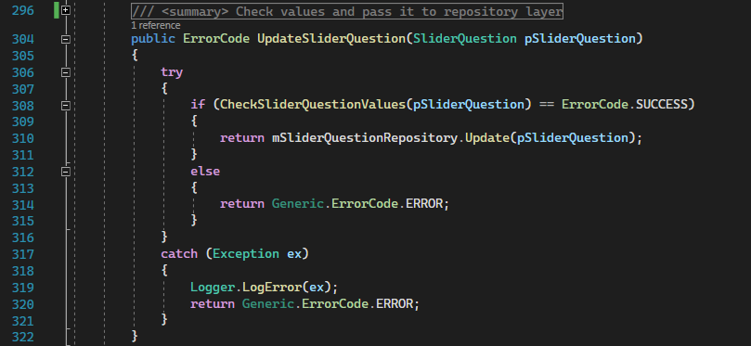

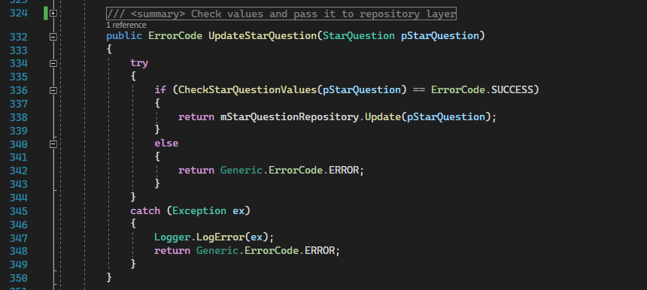

Description:

All of these methods validate their corresponding passed question and pass them to their corresponding repository layer.

**Get Question Functions**

GetSmileyQuestionByID, GetSliderQuestionByID, GetStarQuestionByID & GetAllQuestions:

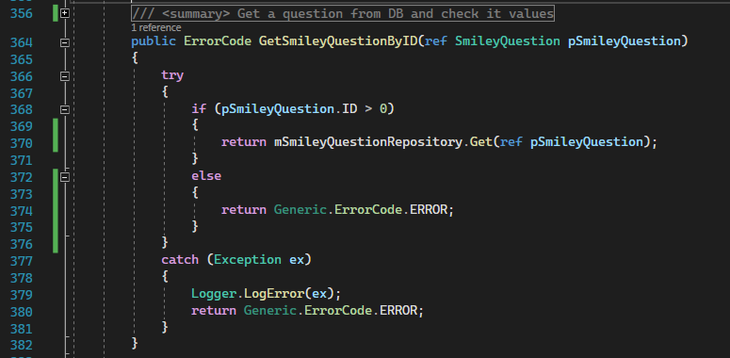

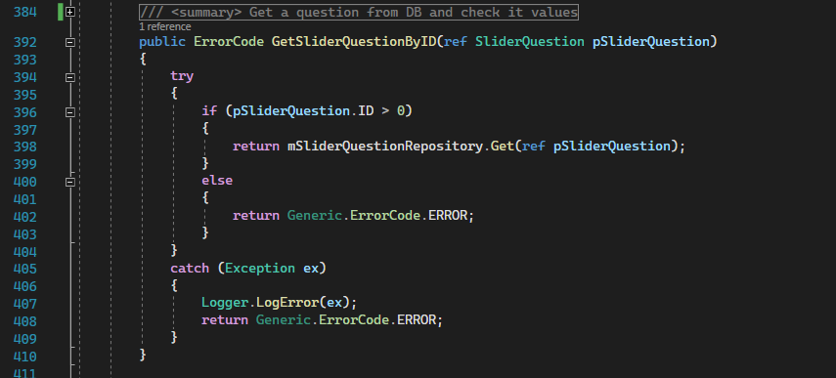

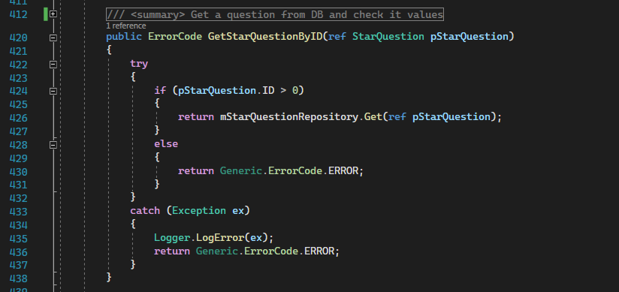

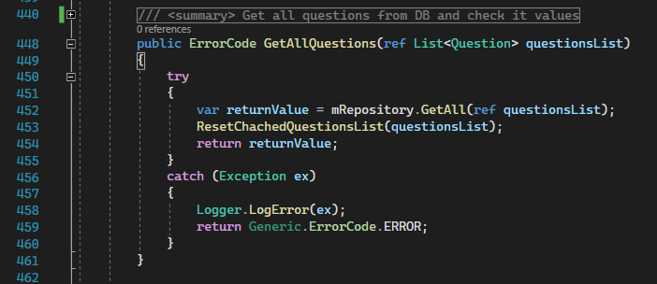

Description:

All of these methods validate their corresponding passed question and pass them to their corresponding repository layer.

**Delete Question Functions**

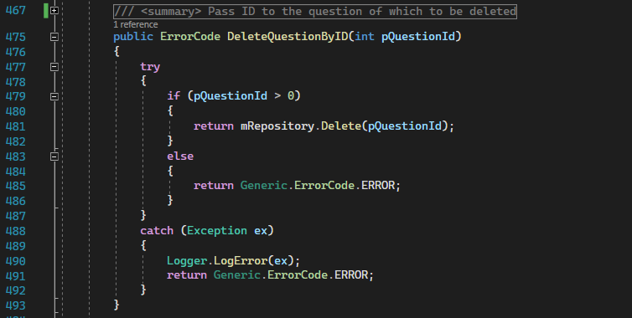

Description:

This method validate question and pass them to its corresponding repository layer.

**Validation Functions**

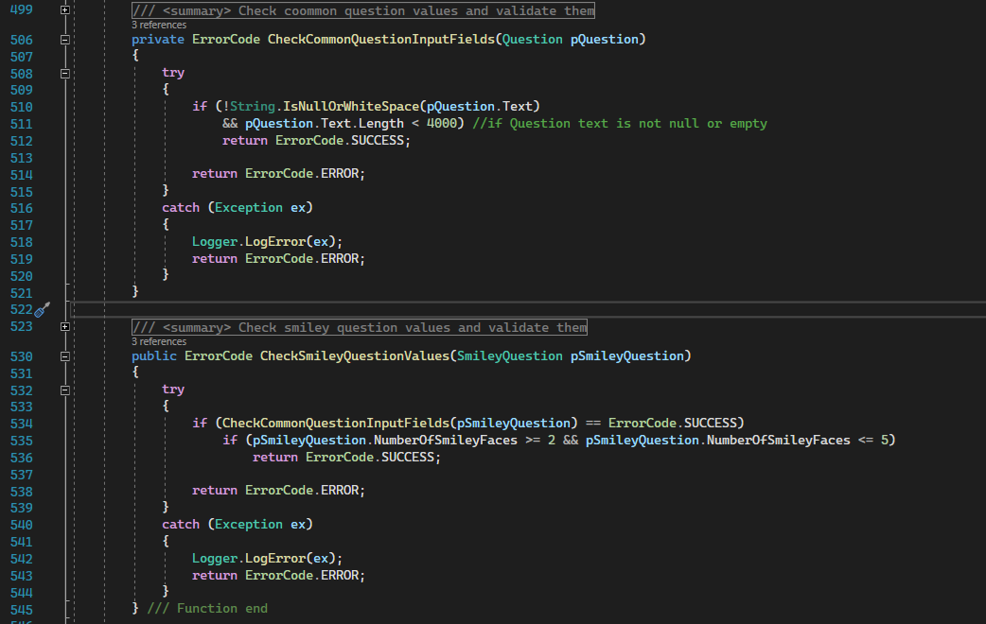

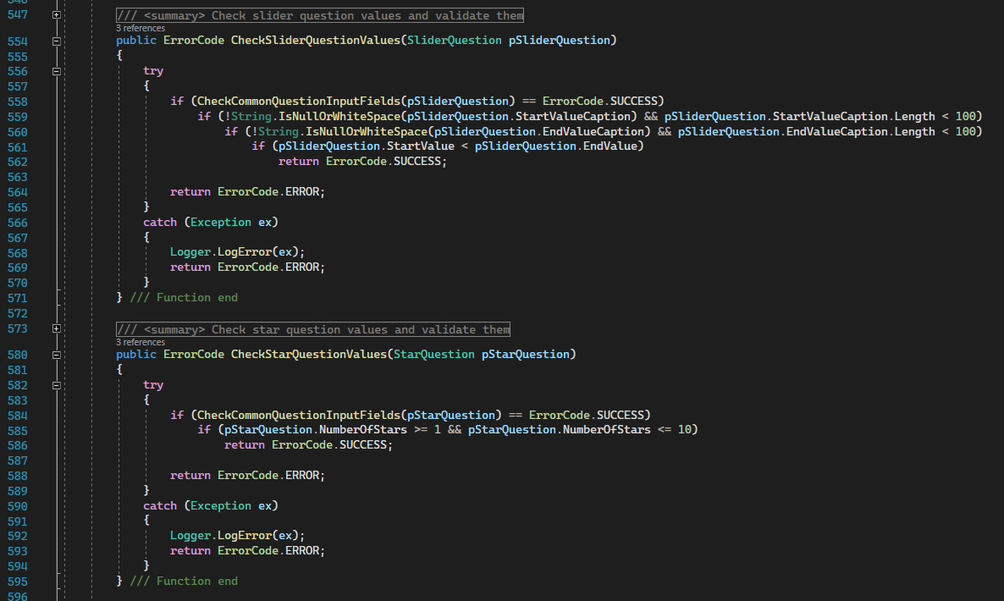

These functions validate their passed question and return their corresponding ErrorCode.

**1.5.2 ConnectionSettingsManager**

**Code:**

The code is divided into regions based on their functionality.

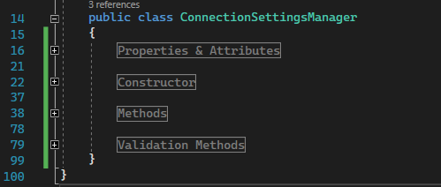

**Properties & Attributes**

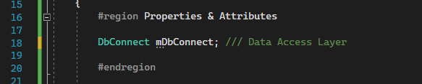

**Constructor**

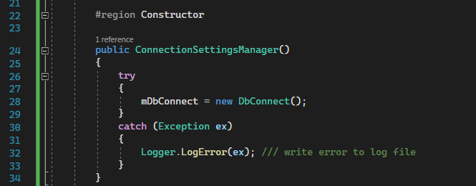

Initialize properties

Methods

GetConnectionString

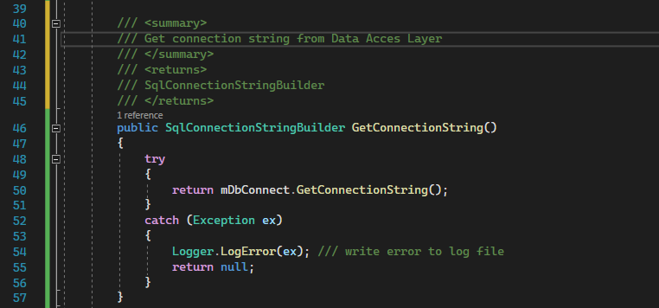

Description:

Get connection string from Data Access Layer

Returns:

SqlConnectionStringBuilder

CheckConnectivity

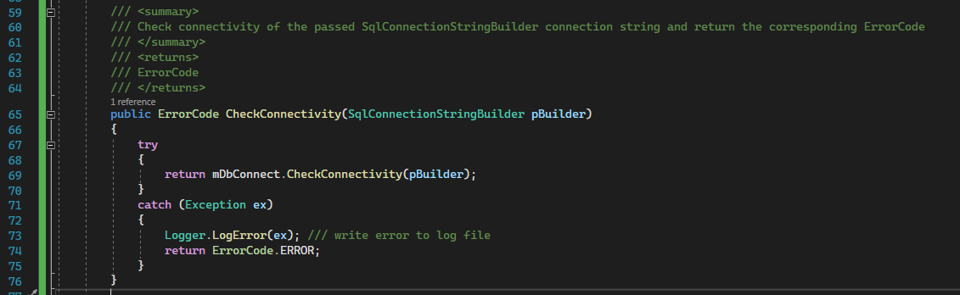

Description:

Check connectivity of the passed SqlConnectionStringBuilder connection string and return the corresponding ErrorCode

Returns:

ErrorCode

SaveConnectionString

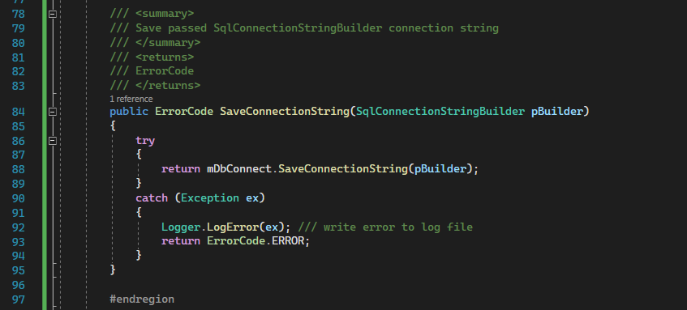

Description:

Save passed SqlConnectionStringBuilder connection string

Returns:  
ErrorCode

**Validation Methods**

CheckConnectionStringInputFields

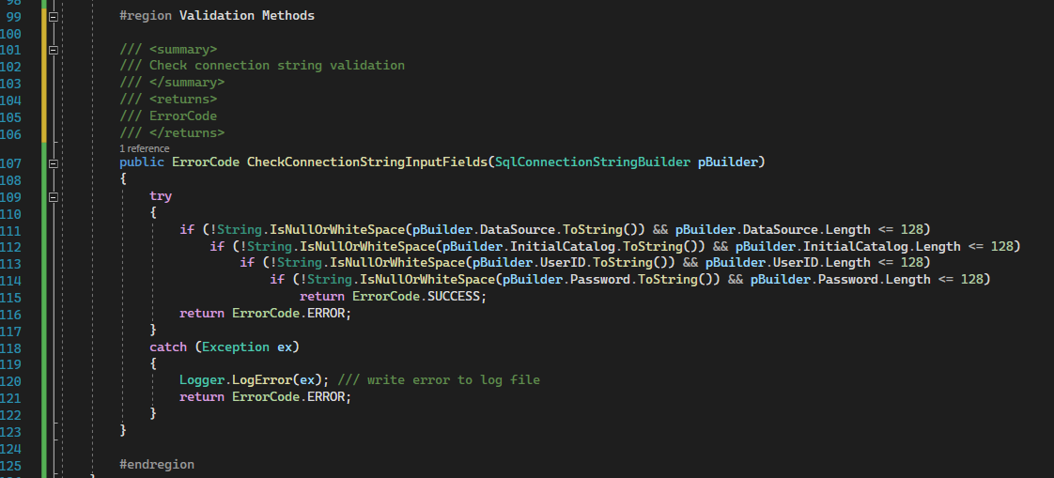

Description:

Check connection string validation

Returns:

ErrorCode

**1.6 Repositories**

**1.6.1 GenericRepository**

This repository is generic and it’s inherited by other more specific repositories.

It has 2 functions:

1. Delete
2. GetAll

**Code:**

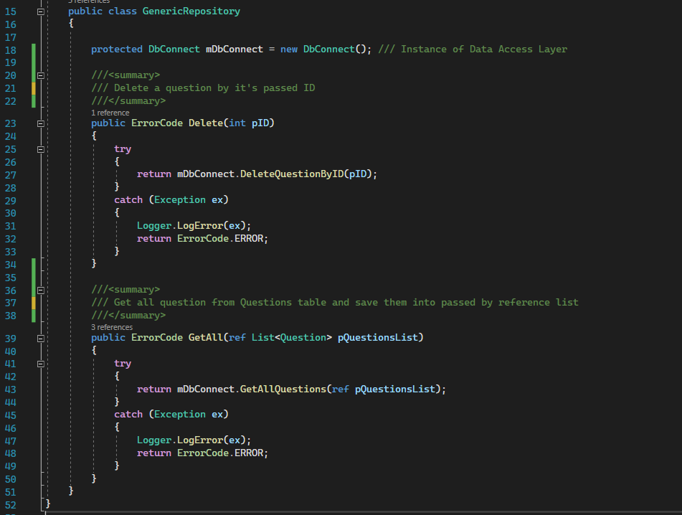

Delete:

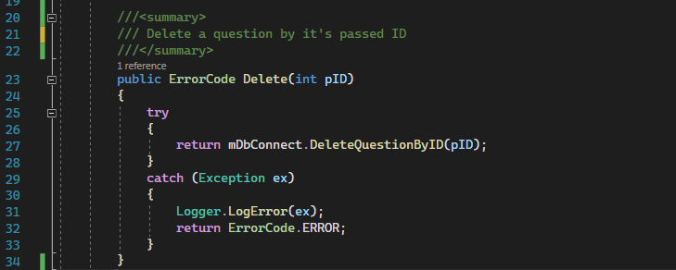

Parameter:

Int pID -> Question ID to be deleted

Description:

Delete a question by its passed ID

Returns:

ErrorCode

GetAll:

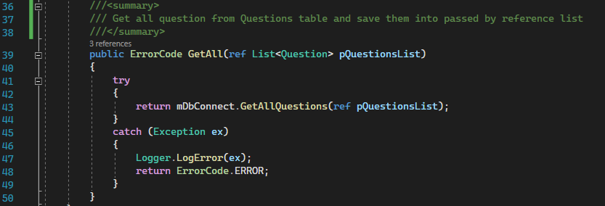

Parameter:

ref List<Question> pQuestionsList

Description:

Get all question from Questions table and save them into passed by reference list

Returns:

ErrorCode

**1.6.2 SliderQuestionRepository**

This class inherits from GenericRepository Class

**Code:**

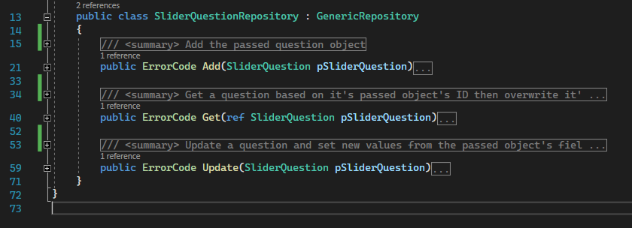

Add:

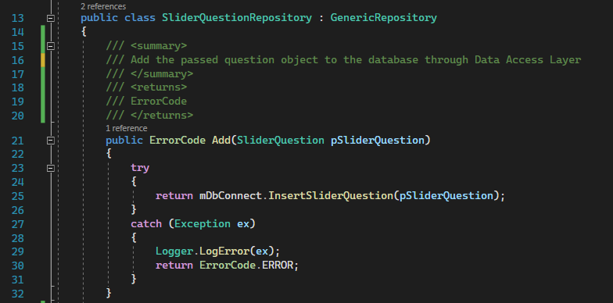

Parameters:

pSliderQuestion-> SliderQuestion

Description:

Add the passed question object to the database through Data Access Layer

Returns:

ErrorCode

Get:

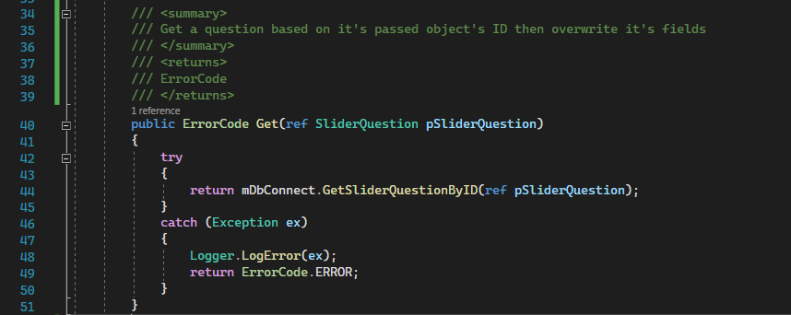

Parameters:

pSliderQuestion-> SliderQuestion

Description:

Get a question based on its passed object's ID then overwrite its fields

Returns:

ErrorCode

Update:

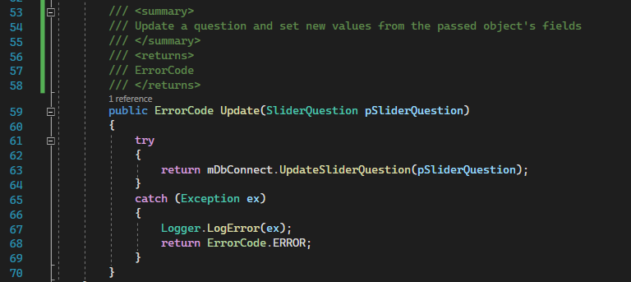

Parameters:

pSliderQuestion-> SliderQuestion.

Description:

Update a question and set new values from the passed object's fields

Returns:

ErrorCode

**1.6.3 SliderQuestionRepository**

This class does the exact functionality that SliderQuestionRepository class in section 3.5.2 does but to its corresponding slider questions

**1.6.4 StarQuestionRepository**

This class does the exact functionality that SliderQuestionRepository class in section 3.5.2 does but to its corresponding star questions

**1.7 Data Access Layer (DbConnect class)**

This class is used to access the database through SQL quires, SQL stored procedures, SQL functions and ADO.NET classes and methods.

**Code:**

The code is divided into regions based on their functionality.

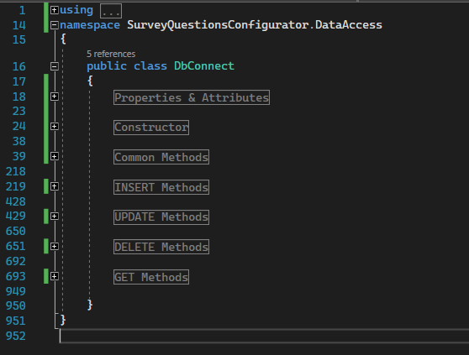

**Properties & Attributes**



mSqlConnectionSettings-> get connection string information from App.config, "connectionStrings" section.

**Constructor**

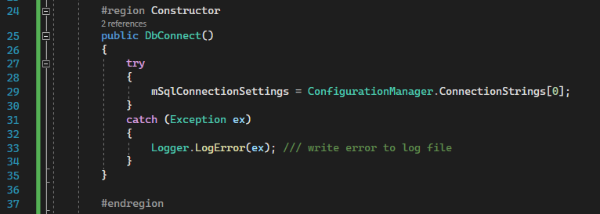

Get the required connection string section from app.config

**Common Methods**

CheckIfOrderExist

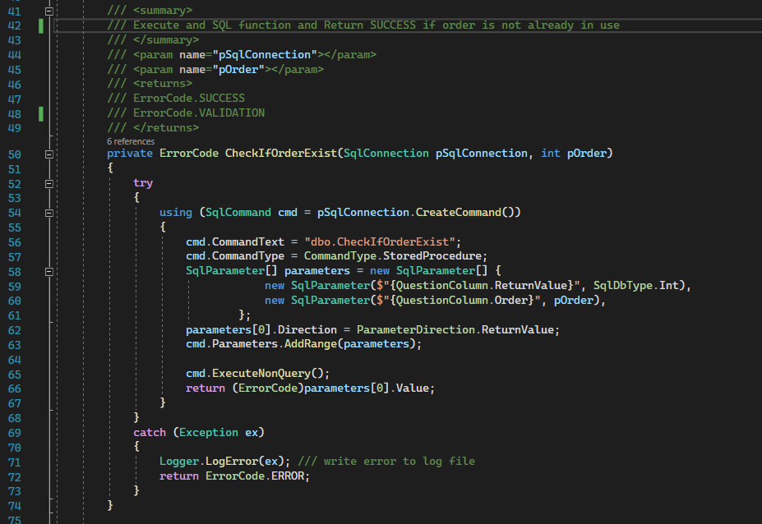

Parameters:

pSqlConnection-> SqlConnection

pOrder-> int

Description:

This function uses an already open SqlConnection and SqlTransaction(TransactionScope) to execute an SQL function. And return ErrorCode.SUCCESS if question order is not taken, ErrorCode.VALIDATION if question order is already in use.

Step 1-> sets an output parameter that saved the returned value form the SQL function.

Returns:

ErrorCode.SUCCESS

ErrorCode.VALIDATION

CheckIfUpdatingSameQuestion:

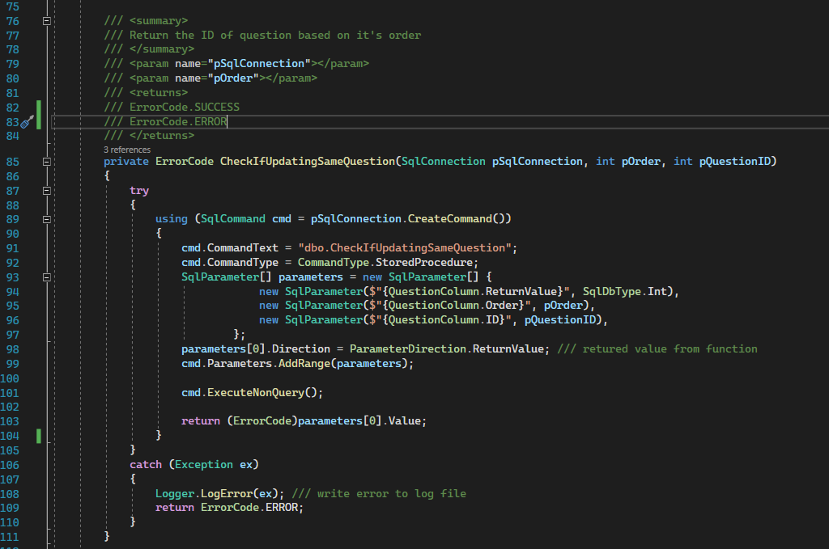

Paramaeters:

pSqlConnection -> SqlConnection

pOrder -> int

pQuestionID -> int

Description:

This function uses an already open SqlConnection and SqlTransaction(TransactionScope) to execute an SQL function.

Checks if the passed question order and ID belongs to the same question or not.

Returns:

ErrorCode.SUCCESS

ErrorCode.VALIDATION

CheckConnectivity:

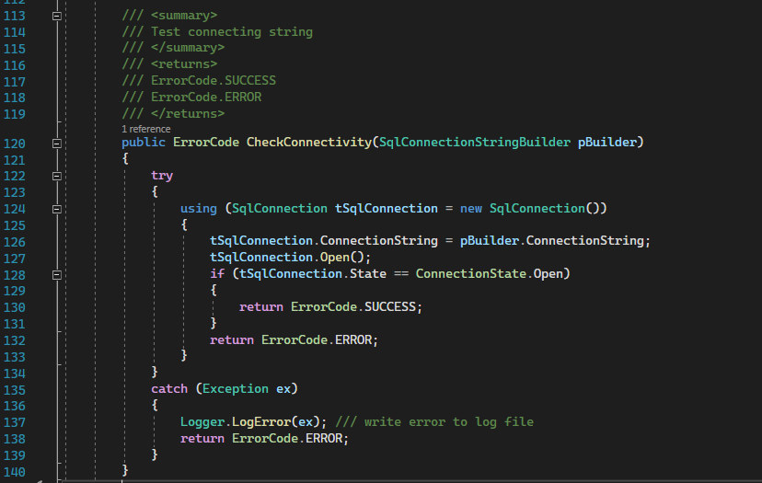

Parameters:

pBuilder-> SqlConnectionStringBuilder

Description:

Check if the passed SqlConnectionStringBuilder.ConnectionString has a valid connection or not.

Returns:

ErrorCode.SUCCESS

ErrorCode.VALIDATION

SaveConnectionString:

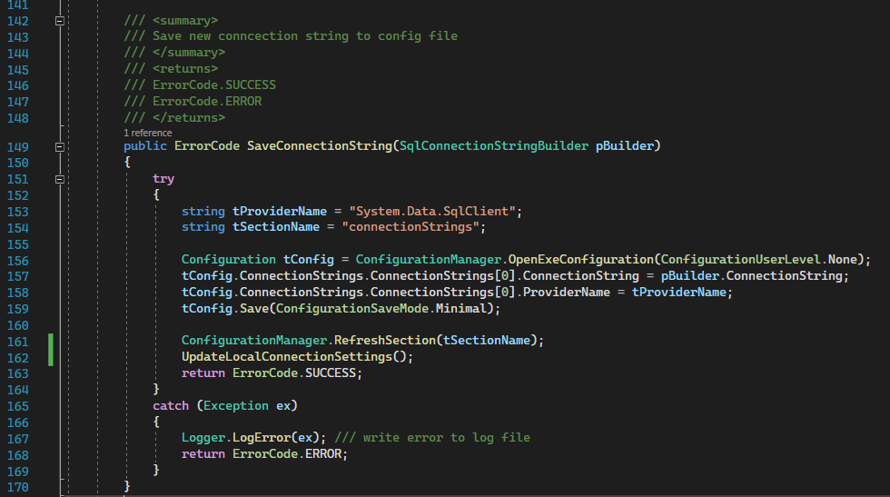

Parameters:

pBuilder-> SqlConnectionStringBuilder

Description:

Saves the passed connection string to the app.config file.

Step 1-> Update local global connecting string with the new saved connection string.

Returns:

ErrorCode.SUCCESS

ErrorCode.ERROR

GetConnectionString:

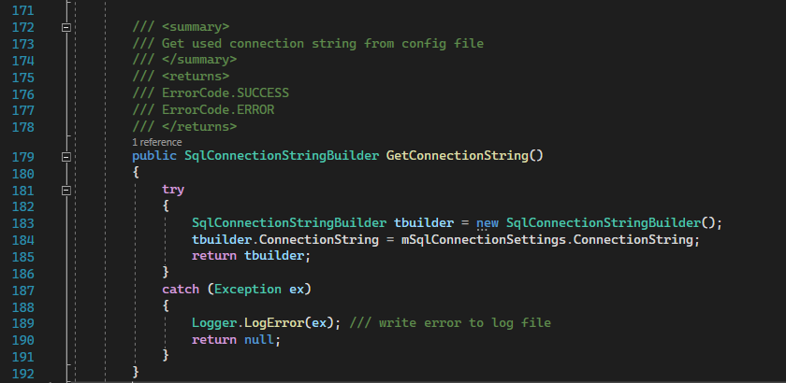

Description:

Get the connection string from app.config file that is saved in mSqlConnectionSettings.

Returns:

SqlConnectionStringBuilder

null

UpdateGlobalConnectionSettings:

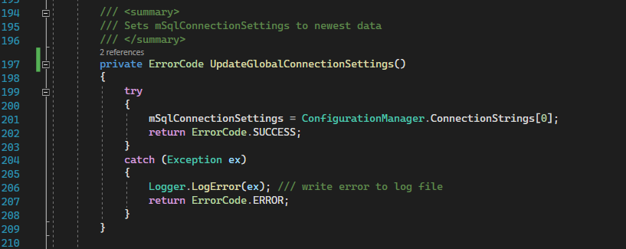

Description:

Update global connecting settings after it was saved in the app.config file

Returns:

ErrorCode.SUCCESS

ErrorCode.ERROR

InsertSmileyQuestion

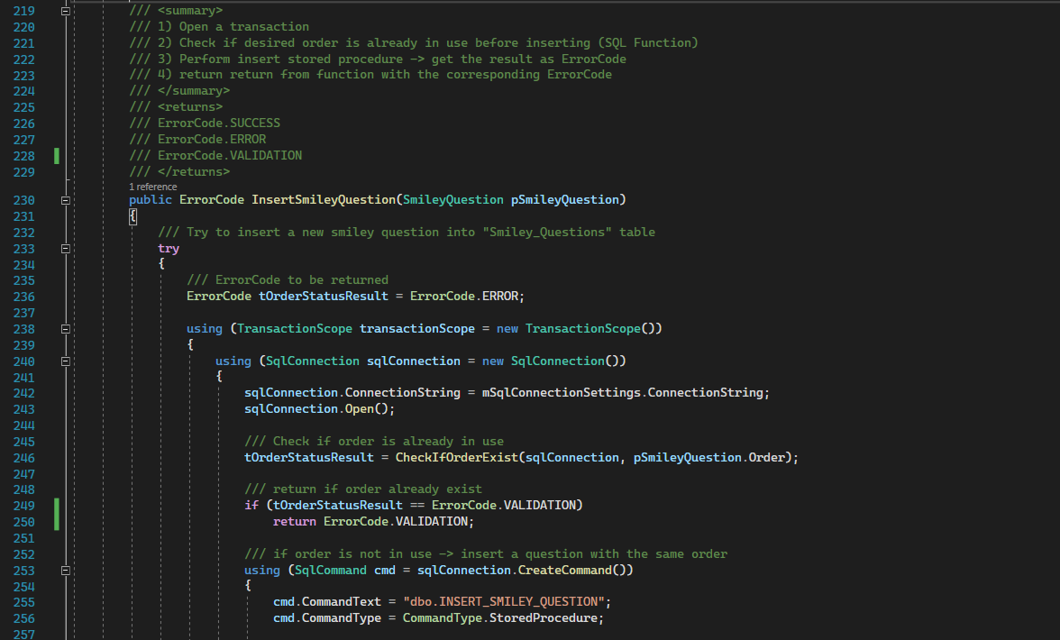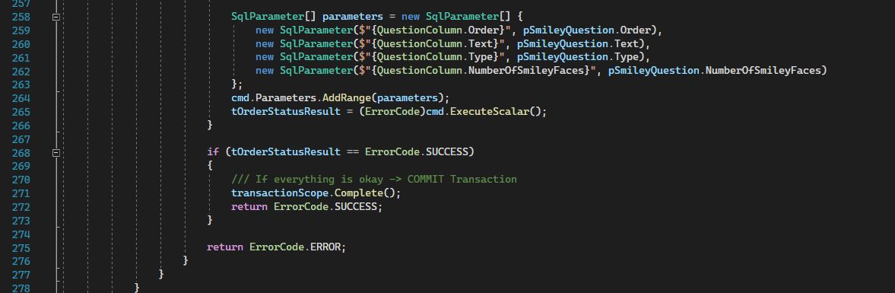

Parameters:

pSmileyQuestion-> SmileyQuestion

Description:

This method opens a transaction then an sql connection, then check if the order of the question to be inserted is taken or not.

Than it executes a stored procedure that insert a smiley question into 2 tables: “Questions” and “Smiley_Questions”

Returns:

ErrorCode.SUCCESS

ErrorCode.ERROR

ErrorCode.VALIDATION

InsertSliderQuestion:

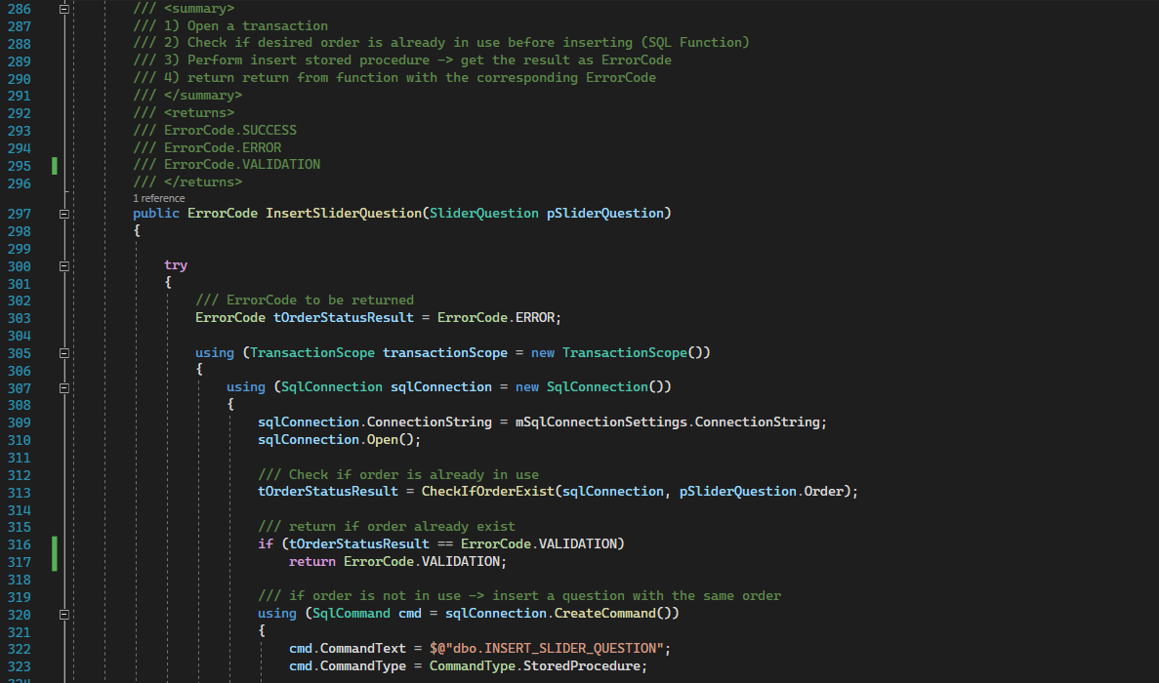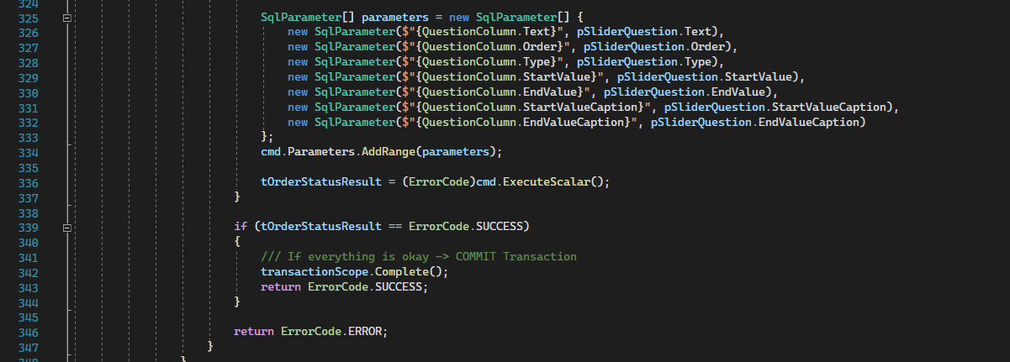

Parameters:

pSliderQuestion-> SliderQuestion

Description:

This method opens a transaction then an sql connection, then check if the order of the question to be inserted is taken or not.

Than it executes a stored procedure that insert a smiley question into 2 tables: “Questions” and “Slider_Questions”

Returns:

ErrorCode.SUCCESS

ErrorCode.ERROR

ErrorCode.VALIDATION

InsertSliderQuestion

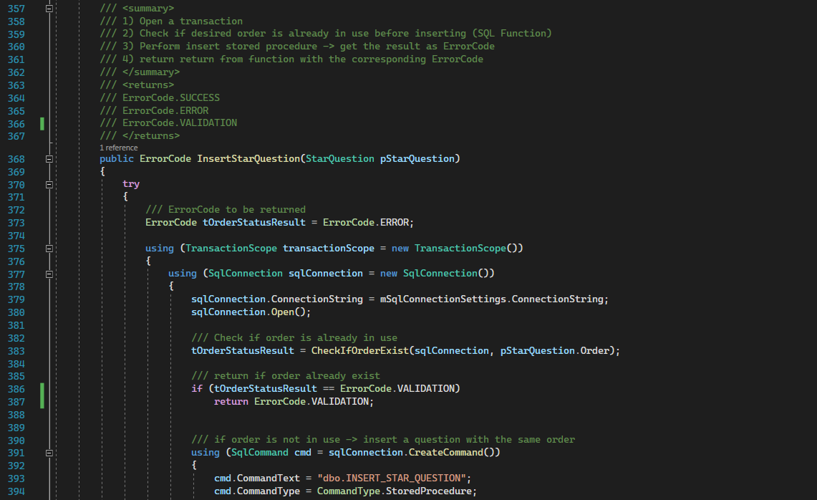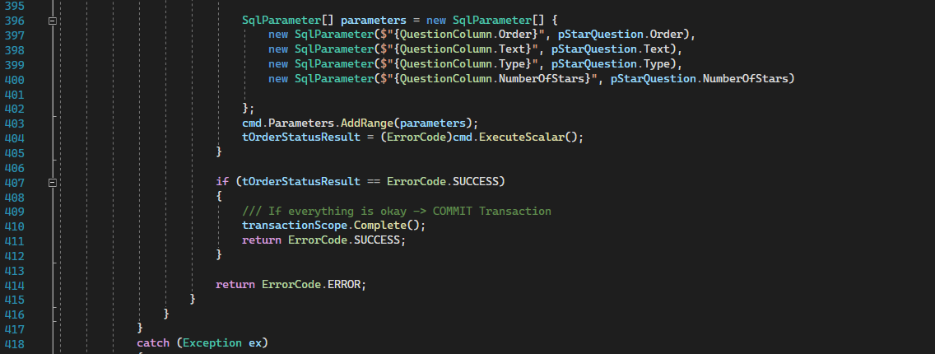

Parameters:

pStarQuestion-> StarQuestion

Description:

This method opens a transaction then an sql connection, then check if the order of the question to be inserted is taken or not.

Than it executes a stored procedure that insert a smiley question into 2 tables: “Questions” and “Star_Questions”

Returns:

ErrorCode.SUCCESS

ErrorCode.ERROR

ErrorCode.VALIDATION

**UPDATE Methods**

UpdateSmileyQuestion

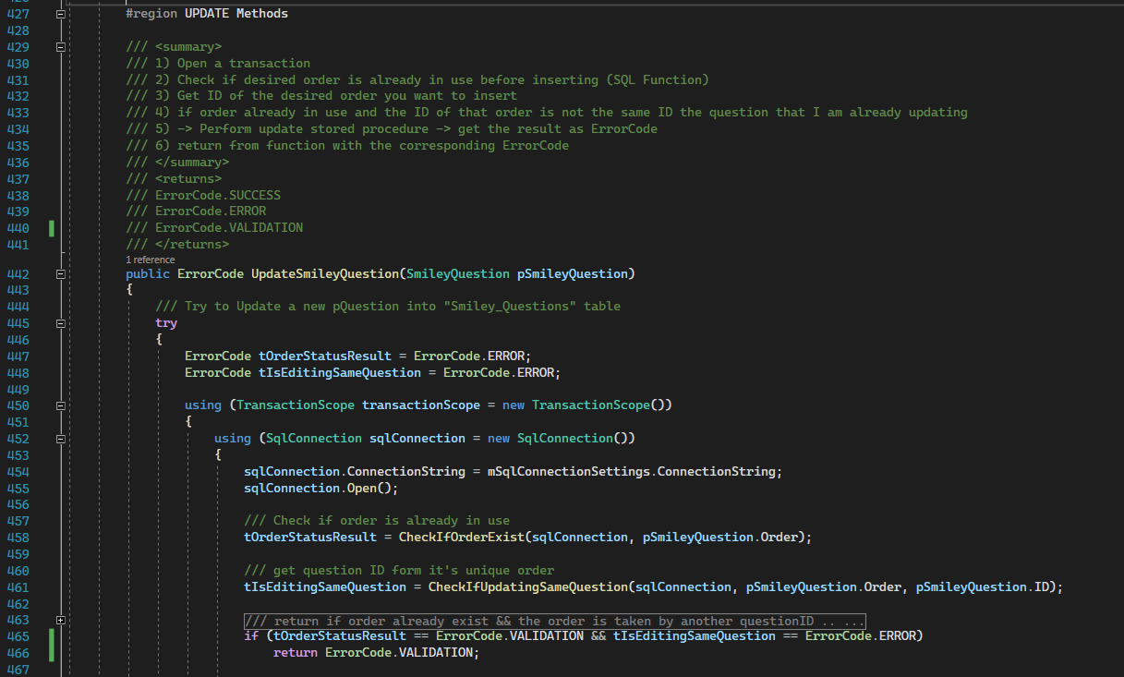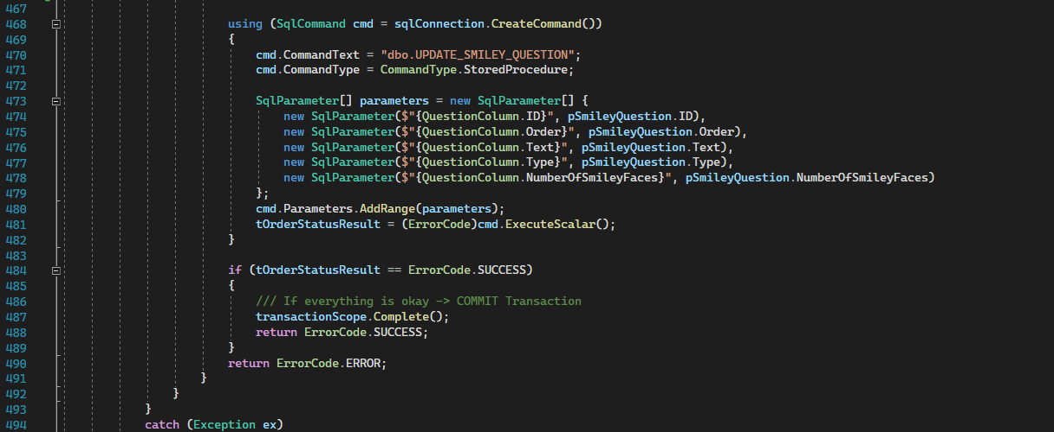

Parameters:

pSmileyQuestion-> SmileyQuestion

Description:

This method opens a transaction then an sql connection, then check if the order of the question to be inserted is taken or not., then check if it’s updating the same question or not.

Then updates to tables: “Questions” and “Smiley_Questions” using stored procedure.

Returns:

ErrorCode.SUCCESS

ErrorCode.ERROR

ErrorCode.VALIDATION

UpdateSliderQuestion:

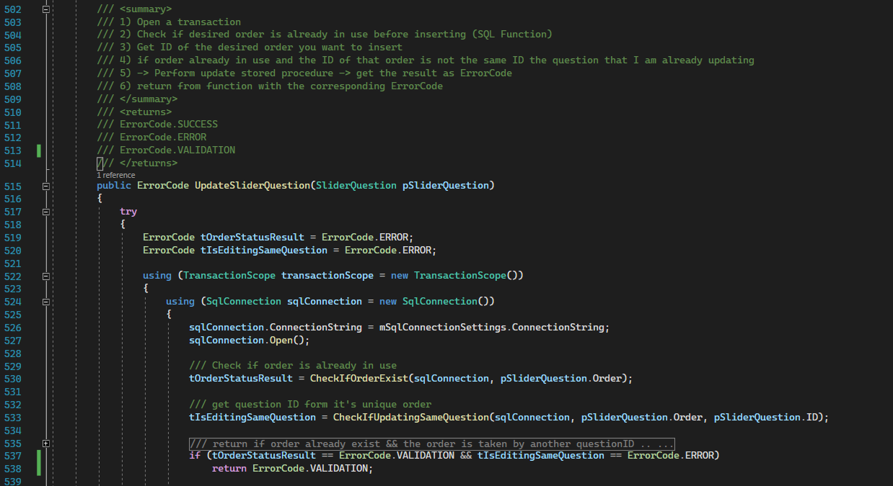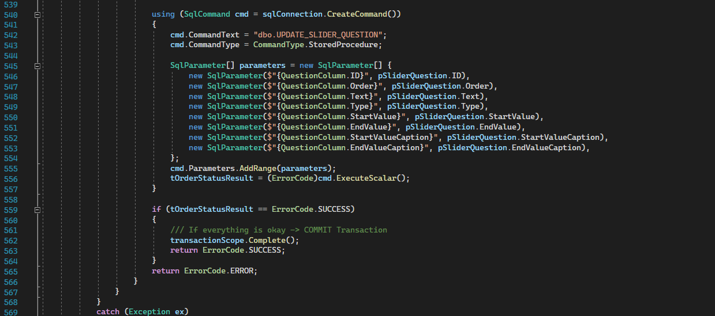

Parameters:

pSliderQuestion-> SliderQuestion

Description:

This method opens a transaction then an sql connection, then check if the order of the question to be inserted is taken or not., then check if it’s updating the same question or not.

Then updates to tables: “Questions” and “Slider_Questions” using stored procedure.

Returns:

ErrorCode.SUCCESS

ErrorCode.ERROR

ErrorCode.VALIDATION

UpdateStarQuestion:

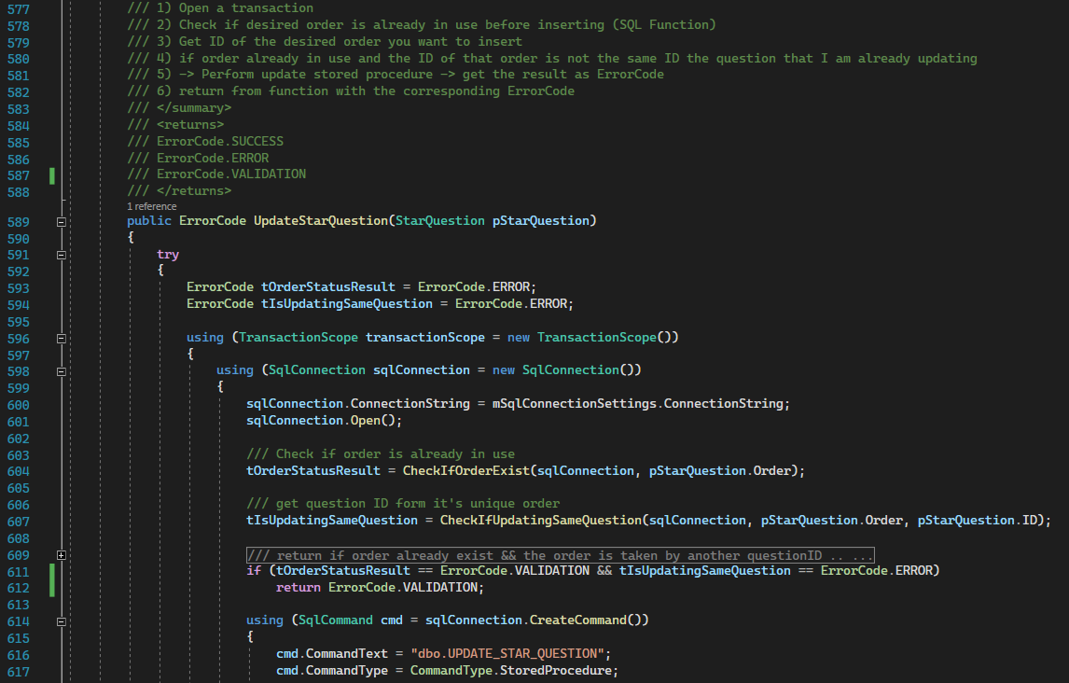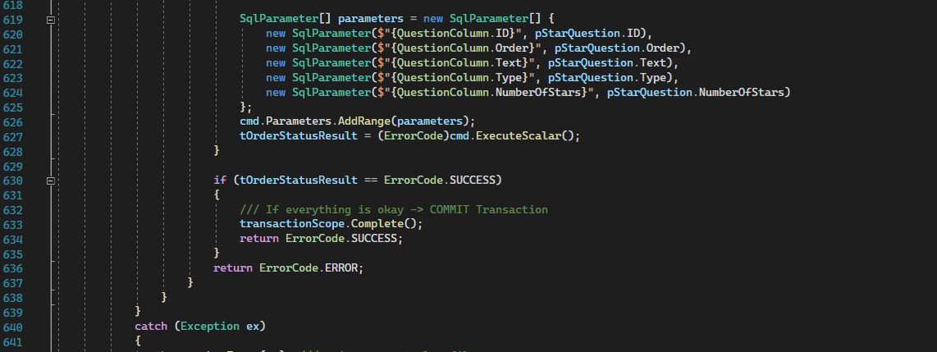

Parameters:

pStarQuestion-> StarQuestion

Description:

This method opens a transaction then an sql connection, then check if the order of the question to be inserted is taken or not., then check if it’s updating the same question or not.

Then updates to tables: “Questions” and “Star_Questions” using stored procedure.

Returns:

ErrorCode.SUCCESS

ErrorCode.ERROR

ErrorCode.VALIDATION

**DELETE Methods**

DeleteQuestionByID

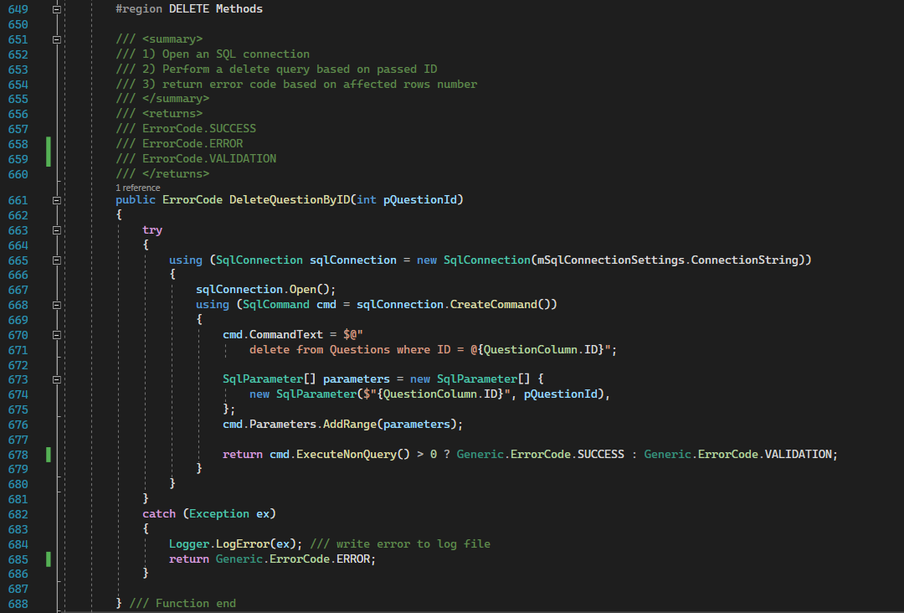

Parameters:

pQuestionId-> int

Description:

This function opens an sql connection and try to execute a query which deletes a question based on the passed ID.

Return value based on the number of rows affected by the operation

Returns:

ErrorCode.SUCCESS

ErrorCode.ERROR

ErrorCode.VALIDATION

**GET Methods**

GetAllQuestions

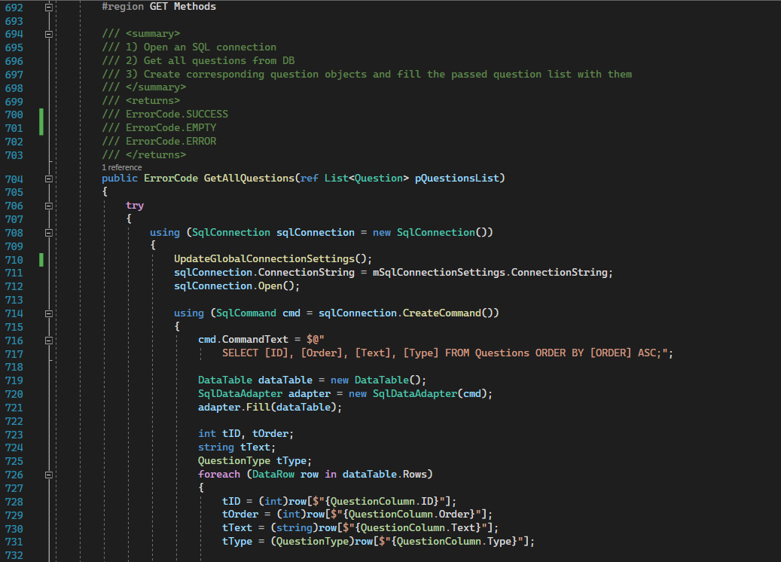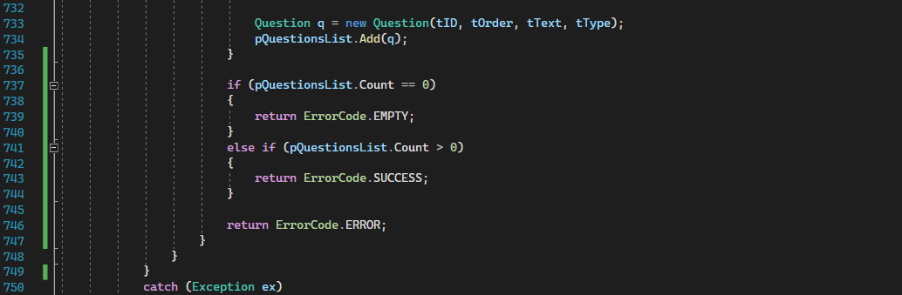

Parameters:

ref pQuestionsList-> List<Question>.

Description:

This method selects all columns from “Questions” table and fill passed pQuestionsList with the returned data.

Returns:

ErrorCode.SUCCESS

ErrorCode.EMPTY

ErrorCode.ERROR

GetSmileyQuestionByID

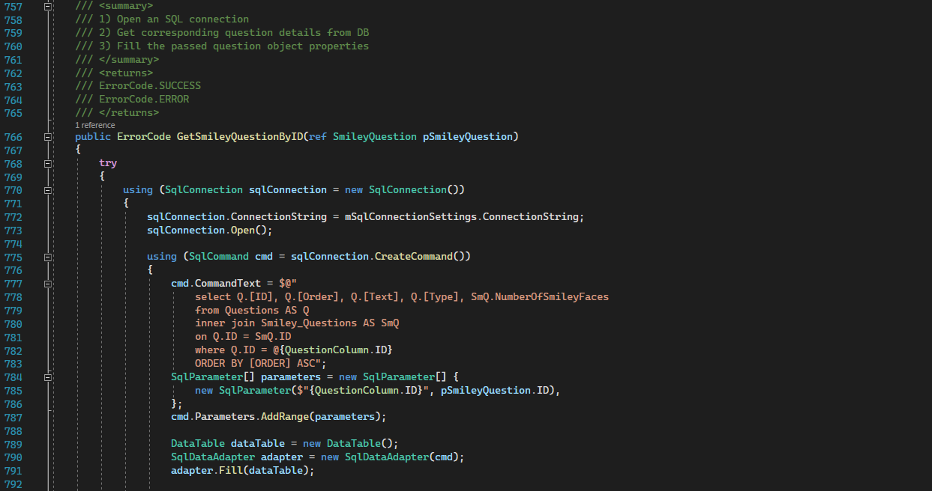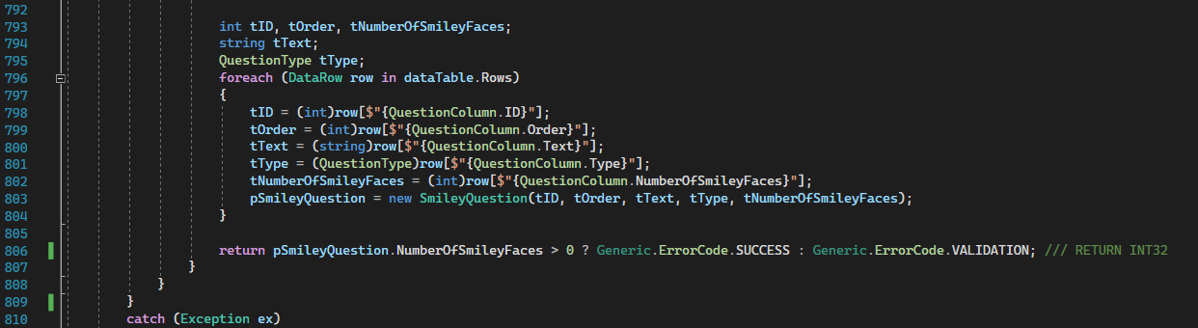

Parameters:

ref pSmileyQuestion-> SmileyQuestion.

Description:

This method selects ID, Order, Text and Type columns from “Questions” table and NumberOfSmileyFaces column from “Smiley_questions” table.

And fill the data with passed object.

Returns VALIDATION if the question was not found (deleted for example)

Returns:

ErrorCode.SUCCESS

ErrorCode.VALIDATION

ErrorCode.ERROR

GetSliderQuestionByID:

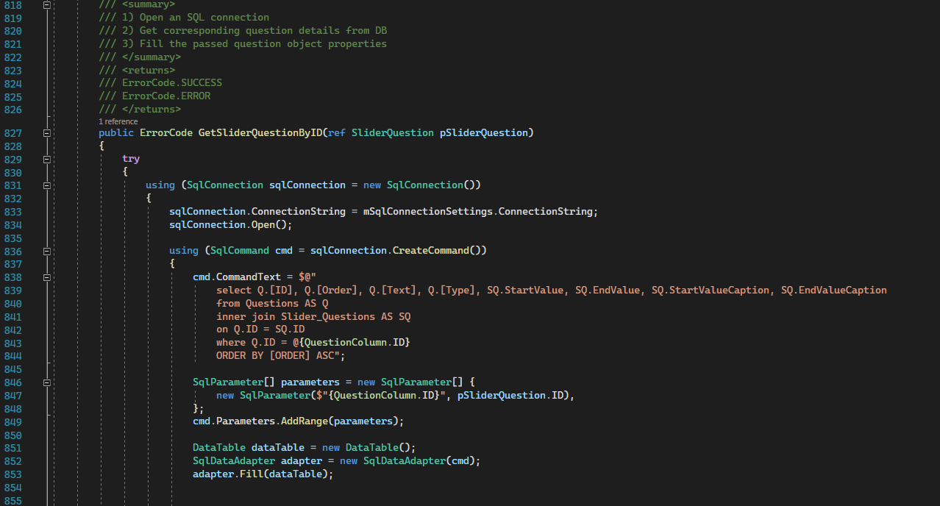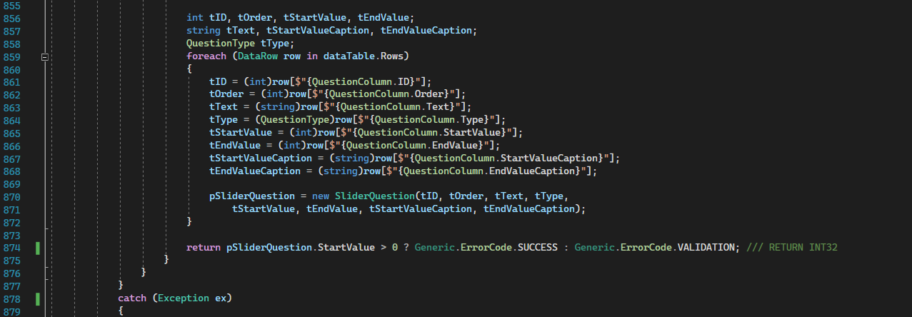

Parameters:

ref pSliderQuestion-> SliderQuestion.

Description:

This method selects ID, Order, Text and Type columns from “Questions” table and StartValue, EndValue, StartValueCaption and EndValueCaption columns from “Slider_questions” table.

And fill the data with passed object.

Returns VALIDATION if the question was not found (deleted for example)

Returns:

ErrorCode.SUCCESS

ErrorCode.VALIDATION

ErrorCode.ERROR

GetStarQuestionByID

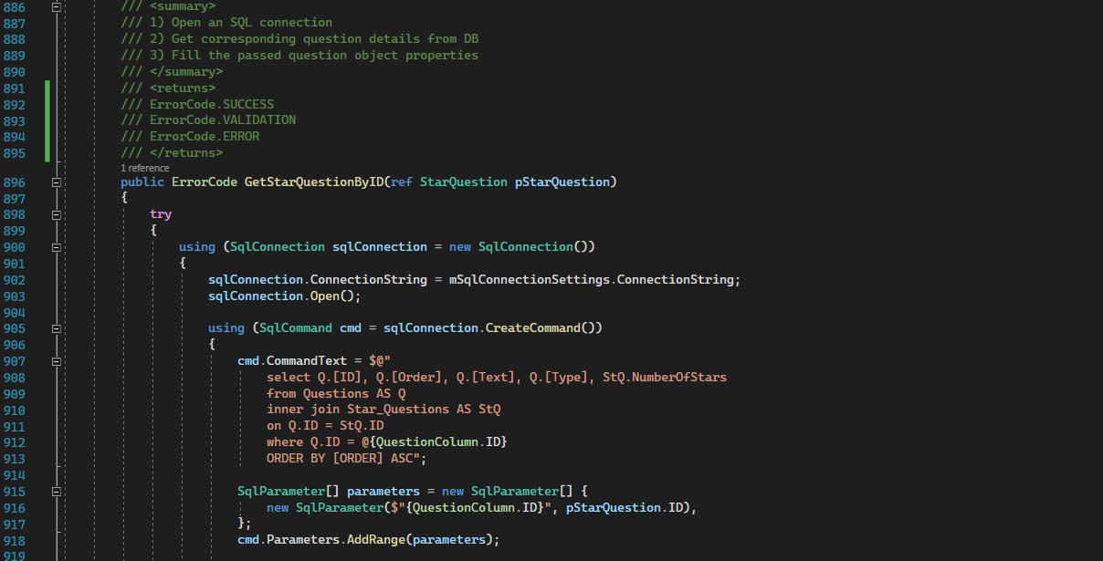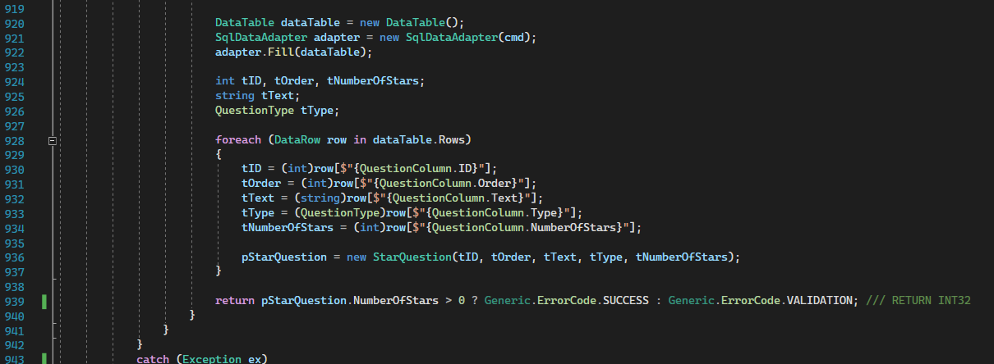

Parameters:

ref pStarQuestion-> StarQuestion.

Description:

This method selects ID, Order, Text and Type columns from “Questions” table and NumberOfStars column from “Star_questions” table.

And fill the data with passed object.

Returns VALIDATION if the question was not found (deleted for example)

Returns:

ErrorCode.SUCCESS

ErrorCode.VALIDATION

ErrorCode.ERROR

**1.8 Entities**

1.8.1 Generic

Code: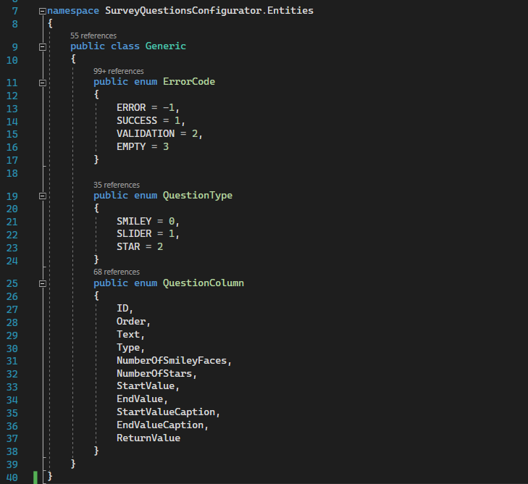

Generic data types that are used across all the application.

**1.8.2 Question**

Code:

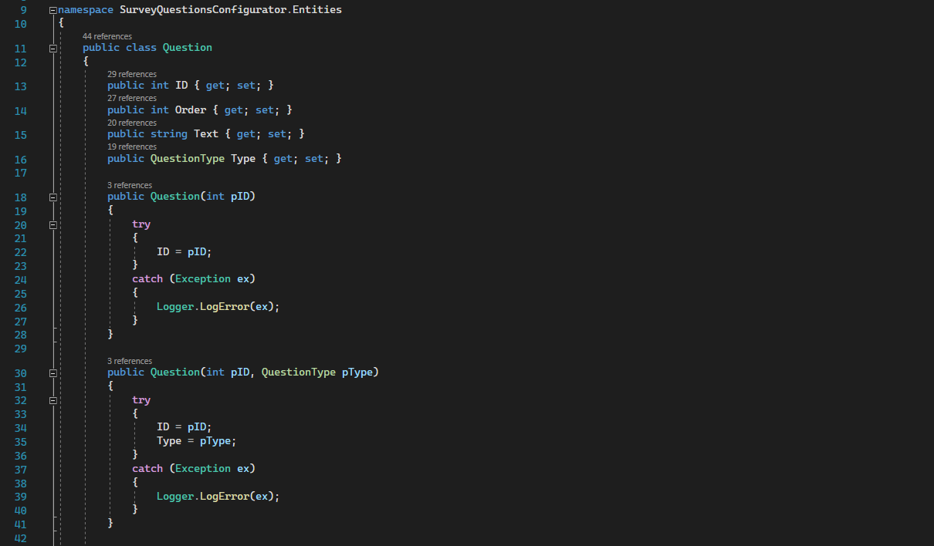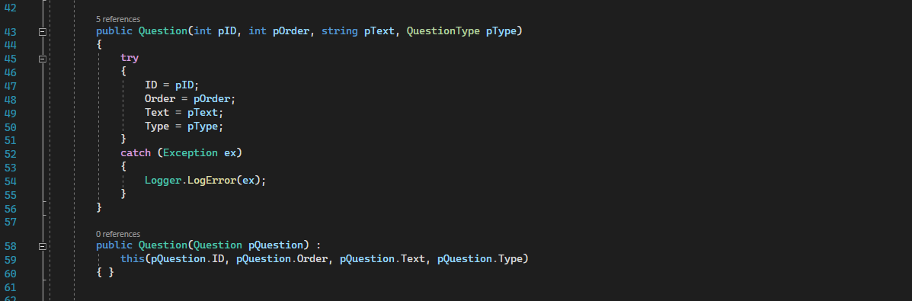

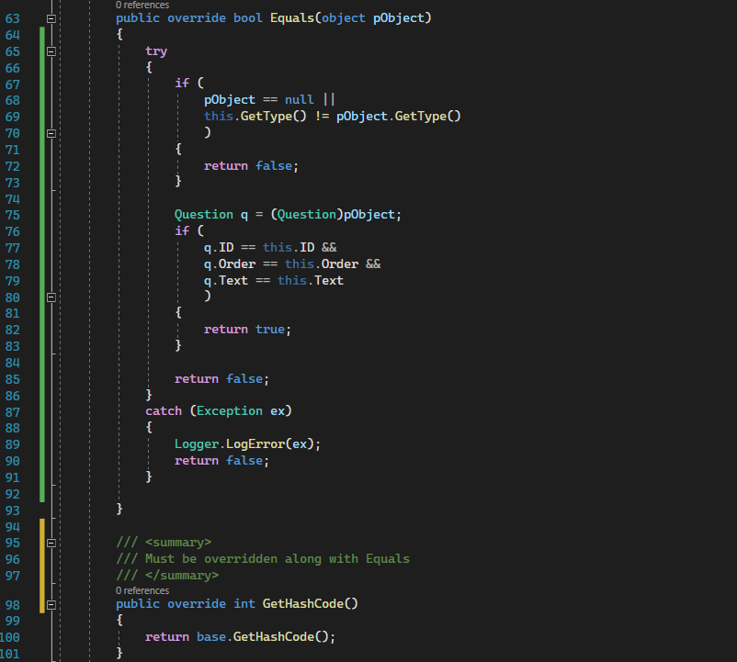

Description:

This generic question type class is inherited by other classes (other question types) and it overrides the “Equals” methods to compare 2 objects of the same type.

It accepts multiple constructors, each one was needed in a specific occasion.

**1.8.3 SmileyQuestion**

Inherits “Question” class and modify its corresponding constructors.

**1.8.4 SliderQuestion**

Inherits “Question” class and modify its corresponding constructors.

**1.8.5 StarQuestion**

Inherits “Question” class and modify its corresponding constructors.

**1.9 Common Helpers**

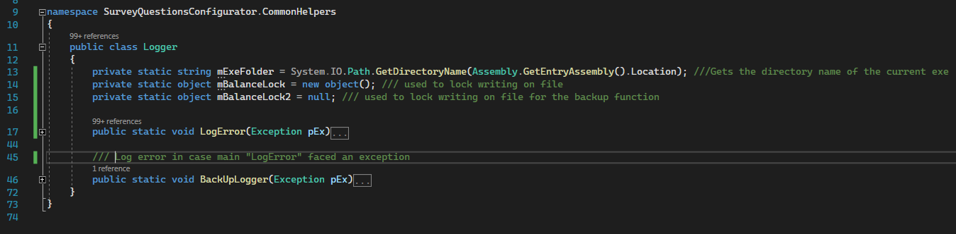

1.9.1 LogError:

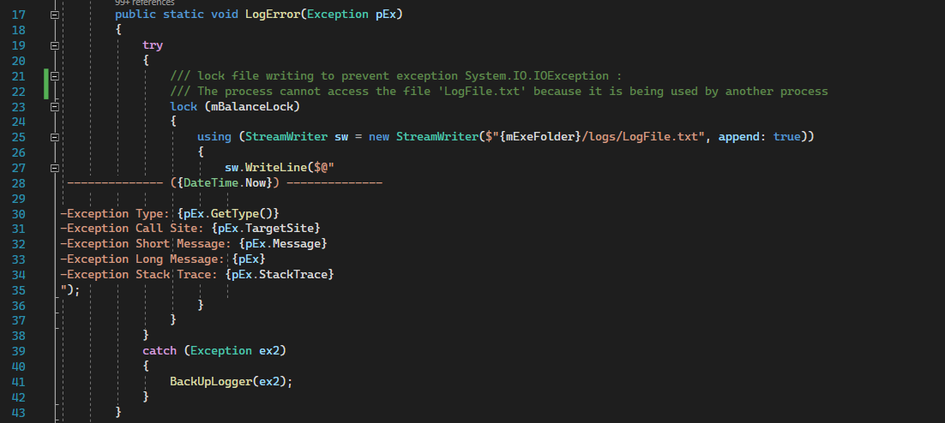

Parameters:

pEx-> Exception

Description:

This function logs any caught error to a log file and write on it using StreamWriter class.

If it fails-> a backup logger will catch and log the error instead.

1.9.2 BackUpLogger:

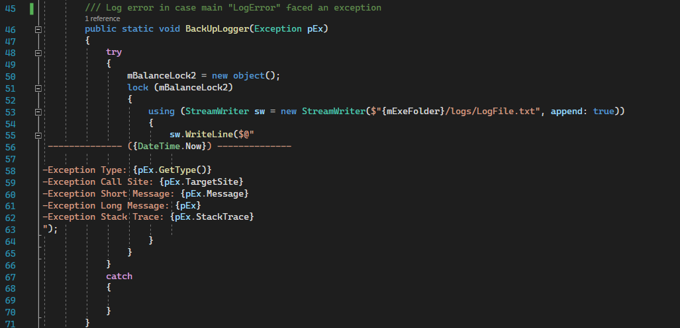

Parameters:

pEx-> Exception

Description:

This function is called in the catch block of the “LogError” function if it faced an exception.